Unit 6 Grade 10 Applied
Quadratic Relations of the Form y = ax² + bx + c

Lesson Outline

BIG PICTURE

Students will:
- manipulate algebraic expressions, as needed to understand quadratic relations;
- identify characteristics of quadratic relations;
- solve problems by interpreting graphs of quadratic relations.
Day | Lesson Title | Math Learning Goals | Expectations
1 | The x Tiles | - Connect the algebraic representations to the graphical representations of quadratics of the forms y = x² + bx + c and  y = (x – r) (x – s).  - Expand and simplify second-degree polynomial expressions involving one variable that consist of the product of two binomials or the square of a binomial, using algebra tiles. | QR1.01, QR2.04  CGE 4b, 5a
2 | Multiply a Binomial by a Binomial Using a Variety of Methods | - Expand and simplify second-degree polynomial expressions involving one variable that consist of the product of two binomials or the square of a binomial, using the chart method, and the distributive property. | QR1.01, QR2.04  CGE 5a, 5b
3 | Find the y-Intercept of Quadratic Equations | - Determine the connections between the y-intercept in the graph of a quadratic relation and the c in the algebraic form y = x² + bx + c, using technology. | QR1.01, QR2.04  CGE 3c, 5a
4 | Finding x-Intercepts and Introduction to Factoring Quadratic Equations | - Determine the connections between the factored form of a quadratic relation and the x-intercepts of its graph.  - Factor simple trinomials of the form x² + bx + c, using a variety of tools, e.g., algebra tiles, paper and pencil, and patterning strategies. | QR1.03, QR2.04  CGE 3c, 7b
5 | Factoring Quadratic Relations of the Form y = ax² + bx + c, Where a Is a Common Factor | - Determine the connections between the factored form and the  x-intercepts of a quadratic relation.  - Factor binomials and trinomials involving one variable up to degree two, by determining a common factor, using algebra tiles. | QR1.02, QR2.04  CGE 5b
6 | Use Intercepts to Graph Quadratic Equations | - Consolidate factoring.  - Connect factors to the x-intercepts of the graph of the quadratic relation.  - Graph quadratic relations, using intercepts. | QR1.02, QR1.03, QR2.04  CGE 3c
7 | We Have a Lot in Common | - Determine the connections between the factored form and the  x-intercepts of the quadratic relation y = x² + bx. | QR1.03, QR2.04  CGE 3c, 5b
8 | What’s the Difference? | - Investigate the method of factoring a difference of two squares using patterning strategies and diagrams.  - Use the technique of factoring the difference of two squares to determine the x-intercepts of a quadratic relation. | QR1.04, QR2.04  CGE 5b, 5e
9 | Quick Sketches of Parabolas | - Use factoring techniques to find zeros and use understanding of the connection between the equation and the y-intercept and symmetry to make “quick” sketches of the related parabola. | QR1.02, QR1.03, QR1.04, QR2.04  CGE 5g
Day | Lesson Title | Math Learning Goals | Expectations
10, 11 | Solve Problems Involving Quadratic Relations | - Solve problems involving quadratic relations by interpreting a given graph or a graph generated with technology from its equation. | QR3.01, QR3.02  CGE 5g
12 | Summative Assessment | Note: A summative performance task is available from the members only section of the OAME web site www.oame.on.ca
13 | Jazz Day

Unit 6: Day 1: The x Tiles |  |  |  | Grade 10 Applied
  75 min |  | Math Learning Goals  - Connect the algebraic representations to the graphical representations of quadratics of the forms y = x² + bx + c and y = (x – r) (x – s).  - Expand and simplify second-degree polynomial expressions involving one variable that consist of the product of two binomials or the square of a binomial, using algebra tiles. |  | Materials  - graphing calculators  - algebra tiles  - BLM 6.1.1,6.1.2, 6.1.3
Assessment
Opportunities
 | Minds On… | Whole Class → Demonstration  Toss a beach ball to a student. Ask the class to describe the path of the ball. Sketch the path of the ball on a graph with the independent axis representing horizontal distance from the teacher and the dependent axis representing height of the ball.  Draw another graph that represents the height of the ball over time (horizontal axis represents time, vertical axis represents the distance from the ground).  Lead a discussion that draws out the characteristics of the resulting parabola (symmetry, axis of symmetry, vertex, zeros, x-intercept, y-intercept). |  | Answer: arc, parabola, equation that has an x²  Word Wall  - axis of symmetry  - vertex  - zeros  - y-intercept  - x-intercepts  Answer: The equations are equal.  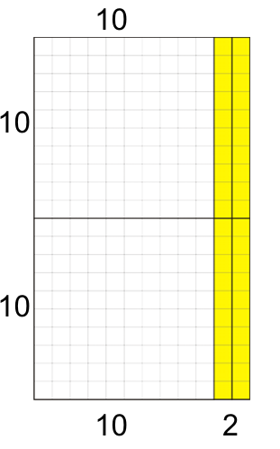  20 × 12  = 100 + 100 + 20 + 20  = 240
 | Action! | Pairs → Investigation  Provide the equation of the form y = x² + bx + c, in its standard and factored forms from BLM 6.1.1.  Students graph both forms, using a graphing calculator (BLM 6.1.2), to determine that they are the same graph and thus the same equation.  Whole Class → Gallery Tour  Post students’ work: the two forms of the algebraic equation, a sketch of the graph, and a table of values. Students view the work of the other pairs.  Debrief:  - What did you notice about the graphs?  - What did you notice about the tables of values?  - What can you infer about the two forms of the equations?  Whole Class → Modelling  - How do we get from one form to the other?  - What is the operation between the two sets of brackets?  - Demonstrate connection to multiplication of 20 × 12, using base-ten materials.  Review algebra tiles: “1” tile (unit tile), x tile, and x² tile.  Using overhead algebra tiles, model the method of multiplying the factors to generate an area which represents the expanded form of the expression,  e.g., x² + 7x + 10, x² + 6x + 8, x² + 6x + 5, x² + 5x + 4, using algebra tiles. Show the connection to multiplication of 20 × 12, using base-ten materials.  Mathematical Process/Using Tools/Observation/Mental Note: Observe students’ use of a graphing calculator to graph quadratic relations.
 | Consolidate Debrief | Individual → Practice  Using algebra tiles, students multiply and simplify three examples with positive terms only.  They make a sketch of the algebra tile solution.  Students check their answers on the graphing calculator by comparing the graphs of the two forms. |  | Virtual tiles are available on various websites.
  y = (x + 4)(x + 3) | y = (x + 2)(x + 5) | y = (x + 3)(x + 2)
Practice |  | Home Activity or Further Classroom Consolidation  Complete the practice questions. Use worksheet 6.1.3 to show your solutions. |  | Provide appropriate practice questions for students.

6.1.1: Quadratic Equations (Teacher)

Cut out each pair of quadratic equations and distribute to the students.

Standard Form | Factored Form
y = x² + 3x + 2 | y = (x + 1)(x + 2)
y = x² + 2x – 3 | y = (x – 1)(x + 3)
y = x² – 1x – 6 | y = (x + 2)(x – 3)
y = x² + x – 6 | y = (x – 2)(x + 3)
y = x² + 5x + 4 | y = (x + 1)(x + 4)
y = x² + 2x – 3 | y = (x + 3)(x – 1)
y = x² – x – 6 | y = (x – 3)(x + 2)
y = x² + 6x + 5 | y = (x + 1)(x + 5)
y = x² – 4x – 5 | y = (x + 1)(x – 5)
y = x² – 4x – 12 | y = (x + 2)(x – 6)
y = x² + 6x + 8 | y = (x + 2)(x + 4)
y = x² – 5x + 6 | y = (x – 3)(x – 2)
y = x² – 2x – 3 | y = (x – 3)(x + 1)
y = x² + 7x + 12 | y = (x + 3)(x + 4)
y = x² + 7x + 10 | y = (x + 2)(x + 5)
y = x² – 7x + 10 | y = (x – 2)(x – 5)
6.1.2: Graphing Quadratic Equations

Name:
1. Obtain a pair of equations from your teacher.
2. Press the Zoom button and press 6 (for ZStandard) to set the window to make the max and min on both axes go from –10 to 10.
3. Press the y = button and key in your two equations into Y₁ and Y₂.
4. To change the graph of Y₂ to “animation”: Move the cursor to the left of Y₂. Press Enter four times to toggle through different graph styles available.
You should see
5. Press Graph. First the Y₁ quadratic will appear, then the Y₂ quadratic will appear and be traced by an open circle.
6. Complete the three columns of the table below.
Our Two Equations | What They  Look Like | What We Think It Means

7. Press 2nd Graph so that you can look at the tables of values for the two curves. Discuss what you see and complete the table.
What We Noticed About the  Table of Values | What We Think It Means
6.1.3: Algebra Tile Template

1. y = ( )( ) = ______________ | 2. y = ( )( ) = ______________
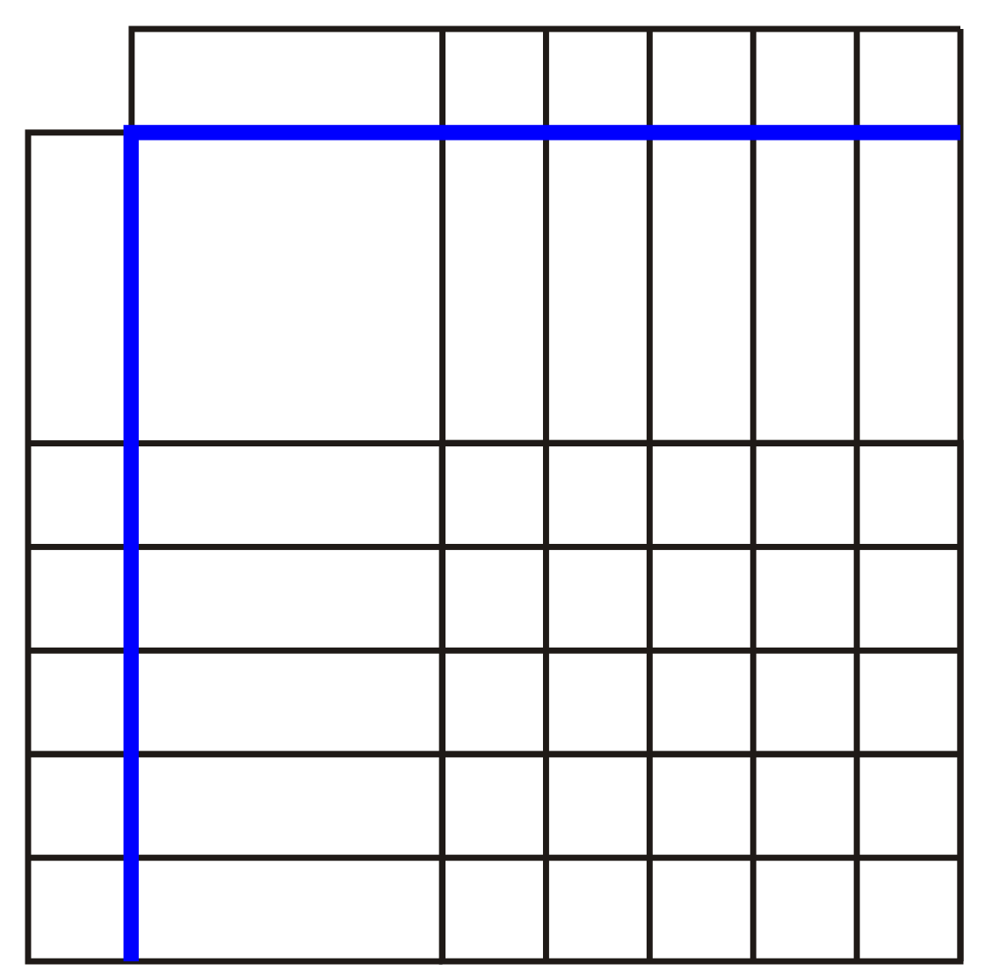
3. y = ( )( ) = ______________ | 4. y = ( )( ) = ______________
5. y = ( )( ) = ______________ | 6. y = ( )( ) = ______________

Unit 6: Day 2: Multiply a Binomial by a Binomial  Using a Variety of Methods |  |  |  | Grade 10 Applied
75 min |  | Math Learning Goals  - Expand and simplify second-degree polynomial expressions involving one variable that consist of the product of two binomials or the square of a binomial, using the chart method, and the distributive property. |  | Materials  - BLM 6.2.1, 6.2.2  - algebra tiles  - graphing calculators
Assessment
Opportunities
 | Minds On… | Whole Class → Discussion  Students expand (x + 1)(x + 1) with algebra tiles.  Discuss the meaning of repeated multiplication, i.e., (x + 1)(x + 1) = (x + 1)².  Individual → Practice  Students practise multiplication of a binomial with positives only, using  BLM 6.2.1 Part A and algebra tiles. |  | Representation with algebra tiles is best for expressions with positive terms only.  This representation can be used for binomials with positive and negative terms.  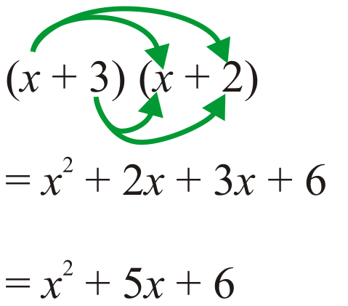  Use visual aid to show double distributive
   | x | +3
  x | x² | 3x
  +2 | 2x | 6
 | Action! | Whole Class → Guided Instruction  Model the different combinations of multiplication, i.e., monomial × monomial and monomial × binomial with positive and negative terms, using the chart method.  Connect the use of algebra tiles to the “chart method.”  Model the chart method for multiplication of a binominal × binomial. Students practise this method, BLM 6.2.1 Part B.  Use algebra tiles to show each of these and recall the distributive property.  x(x + 3)  2(x + 3)  Multiply (x+2)(x+3) using tiles, and show “double distributive,” (the algebraic model).  Model the steps involved in the algebraic manipulation of multiplying a binomial by a binomial. Connect to distributive property by calling it “double distributive.”  Using the Distributive Property  Lead students to understand the connection between the chart method and the algebraic method of multiplying binomials.  (x + 4)(x – 3)  = x (x – 3) + 4(x – 3)  = x² – 3x + 4x – 12  = x² + x – 12  Students practise this method, using BLM 6.2.1 Part C.  Learning Skills/Work Habits/Observation/Checklist: Assess how well students stay on task and complete assigned questions.
   | x | +4
  x | x² | 4x
  –3 | –3x | –12
 | Consolidate Debrief | Individual → Journal  In your journal, write a note to a friend who missed today’s class. Summarize the three methods of multiplying binomials that you worked with. Use words, diagrams, and symbols in your explanation.
Reflection |  | Home Activity or Further Classroom Consolidation  Solve the problems by multiplying the binomials. |  | Provide chart template 6.2.2 and algebra tile template 6.1.3, as needed.

6.2.1: Multiply a Binomial by a Binomial

Name:
Part A
Use algebra tiles to multiply binomials and simplify the following:
1. y = (x + 1)(x + 3) = _________________ |  | 2. y = (x + 2)(x + 3) = ________________

Part B
Use the chart method to multiply and simplify the following:
1. y = (x + 1)(x + 3) = __________________ | 2. y = (x + 2)(x +3) = _________________
3. y = (x + 2)(x – 1) = __________________ | 4. y = (x – 2)(x + 3) = _________________
5. y = (x – 1)(x – 1) = __________________ | 6. y = (x – 1) (x – 2) = _________________
6.2.1: Multiply a Binomial by a Binomial (continued)

Part C

Multiply and simplify the two binomials, using the chart method and the distributive property.
1. (x + 4)(x – 3) | 2. (x – 3)(x – 3)
   | x | +4
  x
  –3
   | x | –3
  x
  –3
3. (x + 2)² | 4. (x + 2)(x – 1)
   | x | +2
  x
  +2
   | x | +2
  x
  –1
5. (x – 2) (x + 1) | 6. (x – 1)²
   | x | –2
  x
  +1
   | x | –1
  x
  –1
7. (x – 1)(x – 2) | 8. (x – 3)(x – 4)
   | x | –1
  x
  –2
   | x | –3
  x
  –4
6.2.1: Multiply a Binomial by a Binomial (continued)

Answers to Part B

1. | y = x² + 4x + 3 | 2. | y = x² + 5x+ 6 | 3. | y = x² + x – 2
   | x | 1
  x | x² | x
  3 | 3x | 3
   | x | 2
  x | x² | 2x
  3 | 3x | 6
   | x | 2
  x | x² | 2x
  –1 | –x | –2
4. | y = x² + x – 6 | 5. | y = x² –2x + 1 | 6. | y = x² – 3x +2
   | x | –2
  x | x² | –2x
  3 | 3x | –6
   | x | –1
  x | x² | –x
  –1 | –x | 1
   | x | –1
  x | x² | –x
  –2 | –2x | 2

Answers to Part C

1. x² + x – 12 | 2. x² – 6x + 9
3. x² + 4x + 4 | 4. x² + x – 2
5. x² – x – 2 | 6. x² – 2x + 1
7. x² – 3x + 2 | 8. x² – 7x + 12

6.2.2: Chart Template for Distributive Property

1. y = ( )( ) = ____________ |  | 2. y = ( )( ) = ____________
3. y = ( )( ) = ____________ |  | 4. y = ( )( ) = ____________
5. y = ( )( ) = ____________ |  | 6. y = ( )( ) = ____________
7. y = ( )( ) = ____________ |  | 8. y = ( )( ) = ____________

Unit 6: Day 3: Find the y-Intercept of Quadratic Equations |  |  |  |  | Grade 10 Applied
  75 min |  | Math Learning Goals  - Determine the connections between the y-intercept in the graph of a quadratic relation and the c in the algebraic form y = x² + bx + c, using technology. |  |  | Materials  - graphing calculators  - BLM 6.3.1, 6.3.2
Assessment
Opportunities
 | Minds On… | Whole Class → Modelling  Pair students, and assign a person A and person B. Ask: What is meant by the  y-intercept of a graph? A answers B. Ask: When we studied linear equations we looked at y = 3x + 2. What did the 2 represent? B answers A.  Explain the value of knowing the y-intercept for graphing.  Mathematical Processes/Communicating/Observation/Mental Note: Circulate as students work in pairs to note their use of mathematical language.
 | Action! | Pairs → Guided Investigation  Pairs complete BLM 6.3.1 to identify the y-intercept of quadratic relations given in standard form and factored form.
 | Consolidate Debrief | Whole Class → Summarizing  Students summarize how the y-intercept of the graph relates to the equation of linear relations and quadratic relations, including why it is valuable to know the y-intercept for graphing.  Connect to the understanding that the y-intercept occurs when x = 0 for any relation, referring to algebraic and graphical forms during the discussions.
Practice |  | Home Activity or Further Classroom Consolidation  Complete worksheet 6.3.2. |  | Provide algebra tiles template 6.1.3 or chart template 6.2.2, as needed.

6.3.1: Finding the y-Intercept of a Quadratic Equation

Name:

1. Use the graphing calculator to find the y-intercept for each of the equations:
Note any patterns you see.
Equation | y-intercept

2. How can you determine the y-intercept by looking at a quadratic equation?

3. Which form of the quadratic equation is easiest to use to determine the y-intercept?
Explain your choice.

4. Using your conclusion from question 2, state the y-intercept of each and check using a graphing calculator.
Equation | y-intercept | Does it check?
Equation | y-intercept | Yes | No

5. Explain the connection between the y-intercept and the value of y when x = 0.

6.3.2: Quadratic Equations

Name:

1. Find the y-intercept for each of the following quadratic equations given in factored form. Write the equations in standard form. Show your work.
a) | standard form:
 | y-intercept:

b) | standard form:
 | y-intercept:

c) | standard form:
 | y-intercept:

standard form:
y-intercept:

2. Find the y-intercept for each of the following quadratic equations:
a) | b)
y-intercept: | y-intercept:

Unit 6: Day 4: Finding x-Intercepts and  Introduction to Factoring Quadratic Equations |  |  |  | Grade 10 Applied
  75 min |  | Math Learning Goals  - Determine the connections between the factored form of a quadratic relation and the x-intercepts of its graph.  - Factor simple trinomials of the form x² + bx + c, using a variety of tools, e.g., algebra tiles, paper and pencil, and patterning strategies. |  | Materials  - graphing calculators  - algebra tiles  - BLM 6.4.1, 6.4.2, 6.4.3
Assessment
Opportunities
 | Minds On… | Whole Class → Demonstration  Review how to find the y-intercept for a quadratic equation given the standard form or factored form.  Introduce x-intercepts for quadratic equations. Model how to make a sketch of the parabola given its y-intercept and two x-intercepts. Place a dot on the y-intercept of 4 and x-intercept of 4 and 1. Ask a student to sketch the graph. Repeat for y-intercept of +6 and x-intercept of –3 and –2.  Each student makes a sketch of the graph y-intercept –6 and x-intercept of –2  and 3. Check the answer.  Lead students to the understanding that knowing the y-intercept and both  x-intercepts can greatly assist in graphing some parabolas of the form  y = x² + bx + c. |  | Remind students of the symmetrical nature of a parabola.  Algebra tiles needed to work through the activity:  one – x² tile  four – x tiles  three – unit tiles  It is recommended that only positive terms be modelled with algebra tiles.  Once the patterns are established using positive terms, extend the patterns to include negatives.
 | Action! | Pairs → Investigation  Students use graphing calculators to investigate the x-intercepts (BLM 6.4.1).  Lead students to realize that equations in factored form help to find the  x-intercepts without a calculator. Establish the need to change equations in standard form to factored form. Tell students that the process is called factoring.  Whole Class → Demonstration  Model the use of algebra tiles and the rectangular area model to factor trinomials, using expression x² + 4x + 3.  Ask: What are the length and width of the rectangle?  Point out that there are no other ways to make rectangles with this set of tiles. Students should note that the dimensions of the rectangle are (x + 1) and  (x + 3). These are called the factors. Identify the x-intercepts of the corresponding relation y = (x + 1)(x + 3).  Students use algebra tiles to factor quadratic expressions (BLM 6.4.2). Remind them that, in building the rectangle, the “lines” or “cracks” must line up.  Individual Practice  Students complete the chart and the questions on BLM 6.4.2. Take up as a class. Students complete BLM 6.4.3 Part A.  Curriculum Expectations/Oral Question/Anecdotal Note: Assess how students make connections between the graph and the quadratic equation.
 | Consolidate Debrief | Whole Class → Summary  Complete BLM 6.4.3 Part B question 1, clarifying each aspect of the question.
Concept Practice |  | Home Activity or Further Classroom Consolidation  Complete worksheet 6.4.3 Part B.

6.4.1: Finding the x-Intercepts of a Quadratic Equation

Name:

To find the x-intercepts:
1. Enter the equation in Y₁. y = x² – x – 6
2. Press ZOOM and 6 (Zstandard) to set the scale for your graph. The calculator will then show the parabola.
3. Press 2nd TRACE 1 to view the Calculate screen.
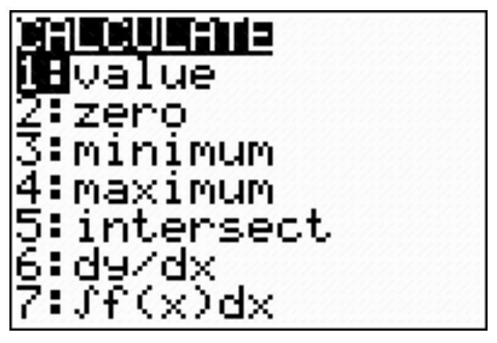

4. Select 2: ZERO. Your screen should be similar to the following screen.
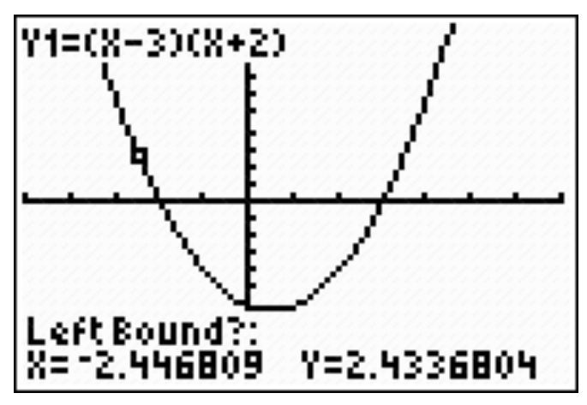

5. You will be asked to enter a left bound. You can move the cursor to the left of one
x-intercept (or just enter an x value that is to the left of the x-intercept). Press ENTER.
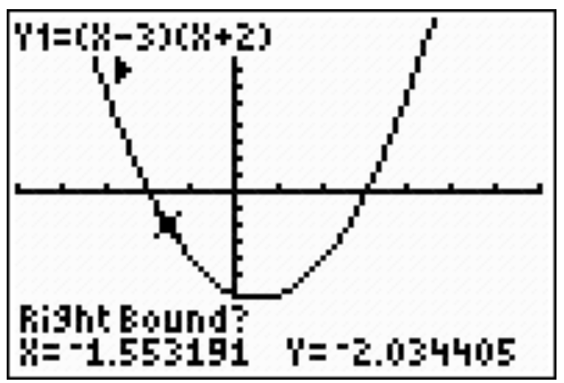

6. Repeat for the right bound, being sure that you are to the right of the same x-intercept.
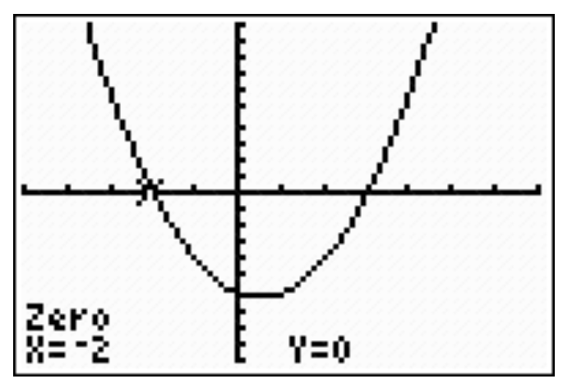

7. The next screen will say guess. You can guess if you want but it is not necessary.
Press ENTER. You will get one x-intercept.

8. Repeat steps 3 through 7 to get the other x-intercept.
6.4.1: Finding the x-Intercepts of a Quadratic Equation (continued)

1. Use the graphing calculator to find the x-intercepts for each of the following:
Equation | First  x-intercept | Second  x-intercept

2. Can you determine the x-intercepts by looking at a quadratic equation? Explain.

3. Which form of the quadratic equation did you find the easiest to use when determining the
x-intercepts? Explain the connection between the factors and the x-intercepts.
6.4.2: Area with Algebra Tiles

Name:

Using algebra tiles create the rectangles for the following areas.
Complete the following chart.
Area of Rectangle | Number  of x² Tiles | Number  of x Tiles | Number of Unit Tiles | Sketch of Rectangle | Length | Width
x² + 4x + 3
x² + 5x + 6
x² + 6x + 8
x² + 7x + 12

1. Find a relationship between the number of x tiles and the numbers in the expressions for the length and width.

2. Find a relationship between the number of unit tiles and the numbers in the expressions for the length and width.

3. If the area of a rectangle is given by x² + 8x + 15, what expression will represent the length and the width?
6.4.3: Factoring Using Algebra Tiles and
Making Connections to the Graphic

Name:
Part A
For each of the following, shade in the appropriate rectangular area. Then shade in the tiles that represent the length and width for each of those areas. Use the length and width to represent and state the factors. State the x-intercepts. Check using a graphing calculator.

1. y = x² + 3x + 2 = ( )( ) |  | 2. y = x² + 5x + 4 = ( )( )
x-intercepts _____, _____  Check with calculator. |  | x-intercepts _____, _____  Check with calculator.

3. y = x² + 6x + 5 = ( )( ) |  | 4. y = x² + 4x + 4 = ( )( )
x-intercepts _____, _____  Check with calculator. |  | x-intercepts _____, _____  Check with calculator.

6.4.3: Factoring Using Algebra Tiles and
Making Connections to the Graphic (continued)

Part B
Using the diagrams in Part A, find the x- and y-intercepts for each quadratic relation.
Use the information to make the sketch on the grid provided.
1. standard form:  y = x² + 3x + 2 | 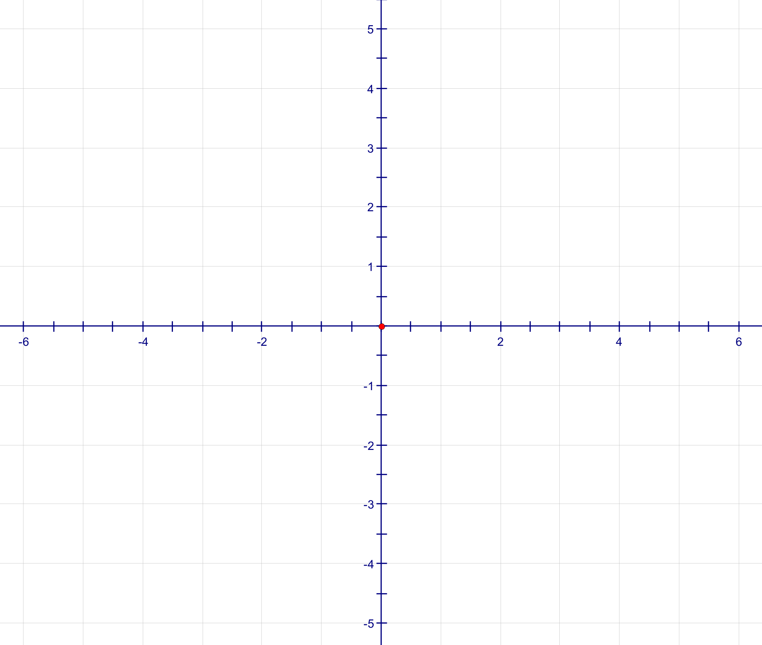
factored form:
y-intercept:
first x-intercept:
second x-intercept:

2. standard form:
y = x² + 5x + 4
factored form:
y-intercept:
first x-intercept:
second x-intercept:

6.4.3: Factoring Using Algebra Tiles and
Making Connections to the Graphic (continued)

3. standard form:
y = x² + 6x + 5
factored form:
y-intercept:
first x-intercept:
second x-intercept:

4. standard form:
y = x² + 4x + 4
factored form:
y-intercept:
first x-intercept:
second x-intercept:

5. In what way is the last example different from the others?

Unit 6: Day 5: Factoring Quadratic Relations of the Form y = ax² + bx + c,  Where a Is a Common Factor |  |  |  | Grade 10 Applied
  75 min |  | Math Learning Goals  - Determine the connections between the factored form and the x-intercepts of a quadratic relation.  - Factor binomials and trinomials involving one variable up to degree two, by determining a common factor using algebra tiles. |  | Materials  - algebra tiles  - graphing calculators  - BLM 6.5.1, 6.5.2, 6.5.3  - glue stick
Assessment
Opportunities
 | Minds On… | Whole Class → Four Corners  Review the forms of equations and representations of quadratics and label four stations: factored form, standard form, graphical form, and chart or algebra tiles representation. Randomly hand out the cards (BLM 6.5.1).  Students move to the corner for the form represented on their card and check that everyone has the same form. They can help one another express their representation in the other forms and jot them on the back of their cards. They then “find” the other three people holding the related cards.  Groups justify they all have different forms of representations of the same quadratic. Paste these on a single page and post them for a gallery walk.  Curriculum Expectations/Demonstration/Marking Scheme: Collect worksheets and assess students’ understanding of the concepts needed to complete the Home Activity from Day 4. |  | r × s = –6  r + s = –1  –3 and 2  factors are  (x – 3)(x + 2)  x intercepts 3  and –2  In Grade 10 Applied, students only factor  ax² + bx + c when a is a common factor.  Answer:  y = 2x² + 2x + 2  y = 2(x² + x + 1)  i.e., 2 sets of  x² + x + 1  Another similar example:  y = 4x² + 12x + 12
 | Action! | Pairs → Investigation  Students complete BLM 6.5.2.  Discuss the ideas investigated and extend to relations that include negative coefficients for b and c, e.g., y = x² – x – 6. Students should understand that  (r) × (s) = c and r + s = b, yielding factors (x + r)(x + s) and x-intercepts  of –r and –s.  Students complete BLM 6.5.3 and share their solutions on the overhead.  Whole Class → Guided Instruction  Introduce common factoring by displaying overhead tiles for 3x + 3.  Demonstrate that this is 3 groups of (x + 1), thus this can be expressed as 3(x +1). The “common factor” is 3. Repeat for 2x + 4 and 5x – 10.  Display the overhead tiles needed to factor 2x² + 2x + 2.  Ask:  - Can these be placed into groups where each type of tile is equally represented in all groups? Why or why not?  - How many groups did you get? What are the contents of each group?  Show how the factored answer would be expressed.  Complete several more examples, such as: 3x² + 6x + 12, 2x² + 6x – 8,  2x² – 8x + 10, 4x² + 8x + 8.  For 4x² + 8x + 8, some students may think that 2 groups of (2x² + 4x + 4) would be appropriate when 4 groups of (x² + 2x + 2) is the most appropriate answer. Use this example to discuss the greatest common factor.
 | Consolidate Debrief | Individual → Journal  Students summarize how to factor a trinomial, including conditions that make it possible for a trinomial to be factored and how to determine a common factor.
Concept Practice |  | Home Activity or Further Classroom Consolidation  Complete the practice questions. |  | Provide questions that require checking answers by expanding or graphing with technology.

6.5.1: Four Corners

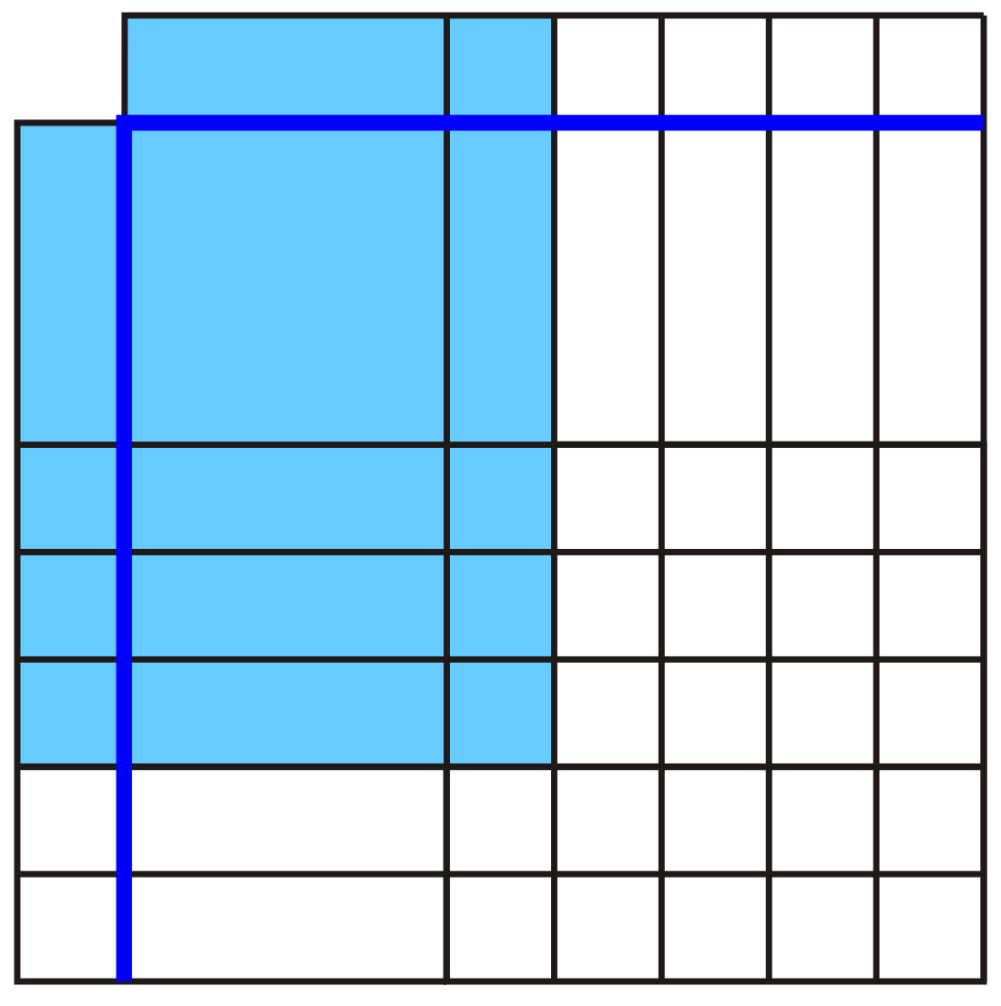 | y = x² + 4x + 3
y = (x + 1)(x + 3) | 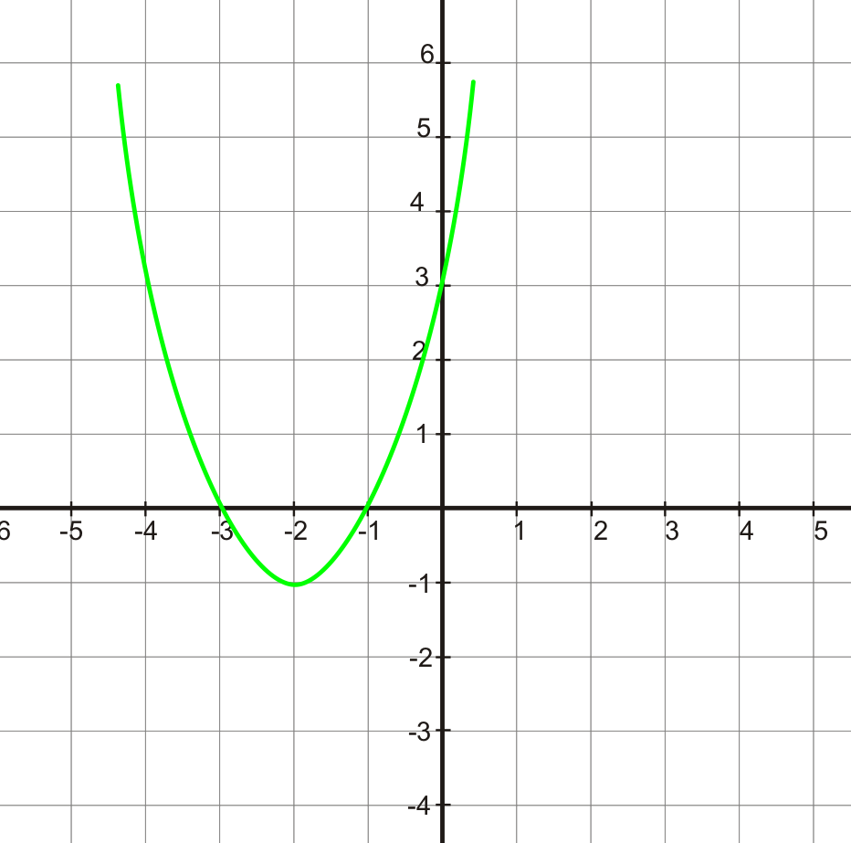
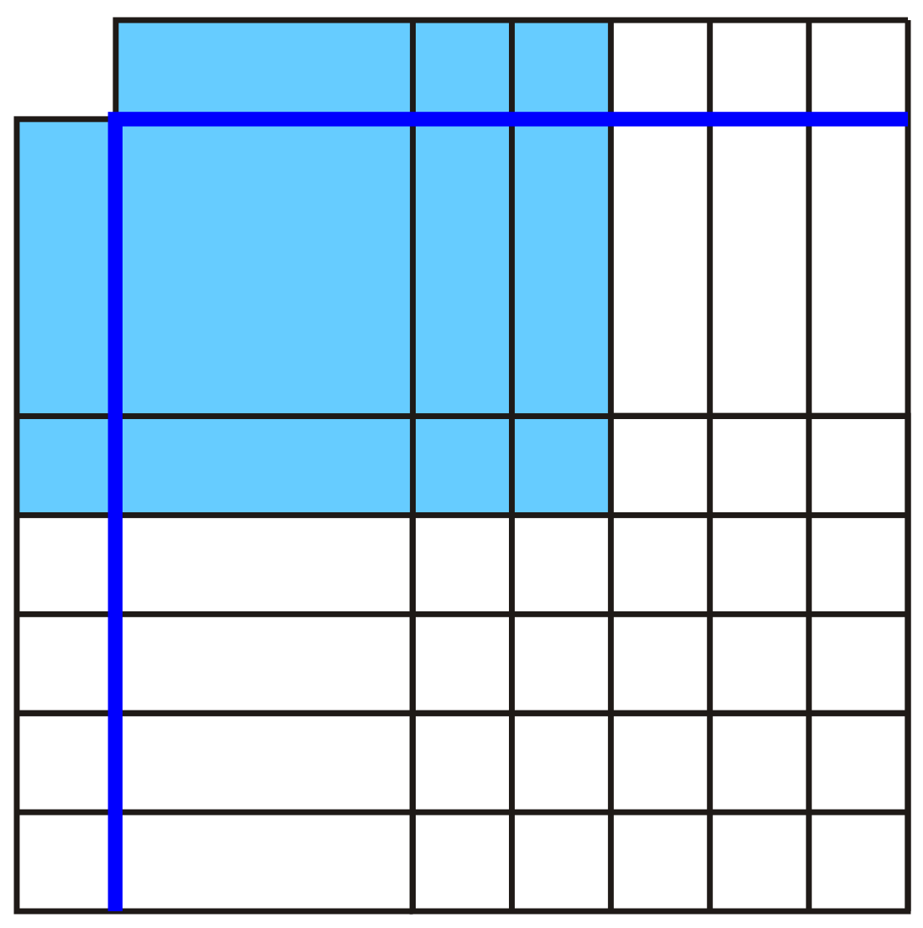 | y = x² + 3x + 2
6.5.1: Four Corners (continued)

y = (x + 2)(x + 1) | 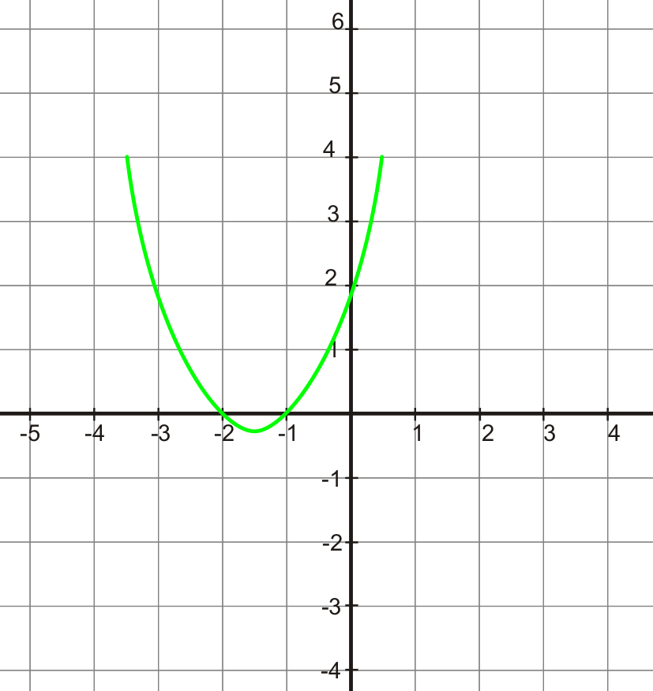
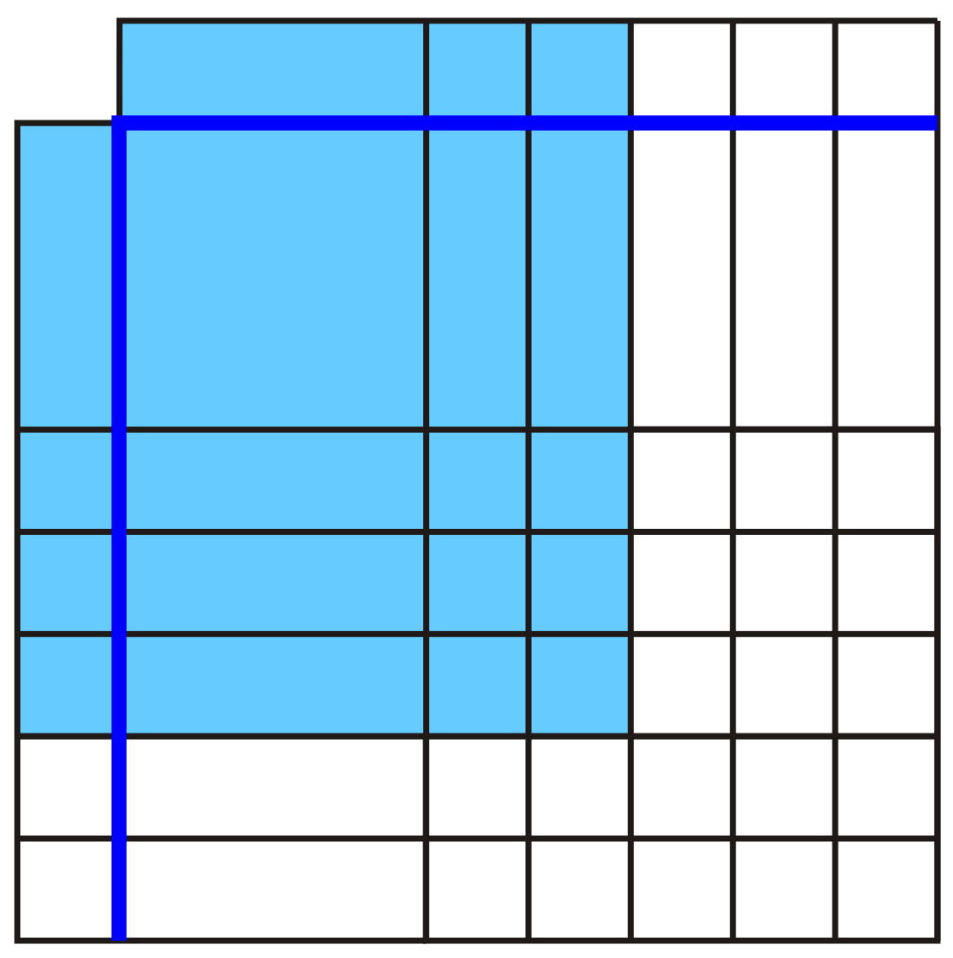 | y = x² + 5x + 6
y = (x + 3)(x + 2) | 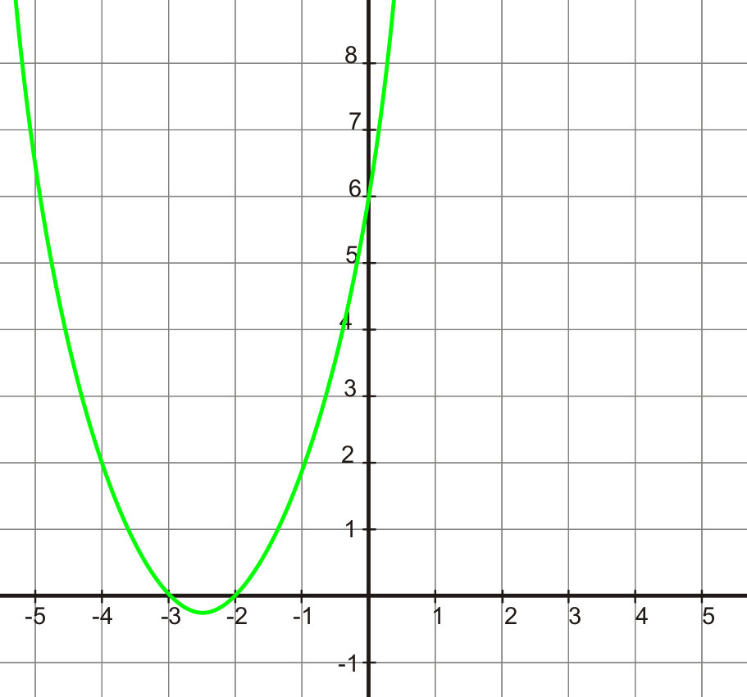
6.5.1: Four Corners (continued)

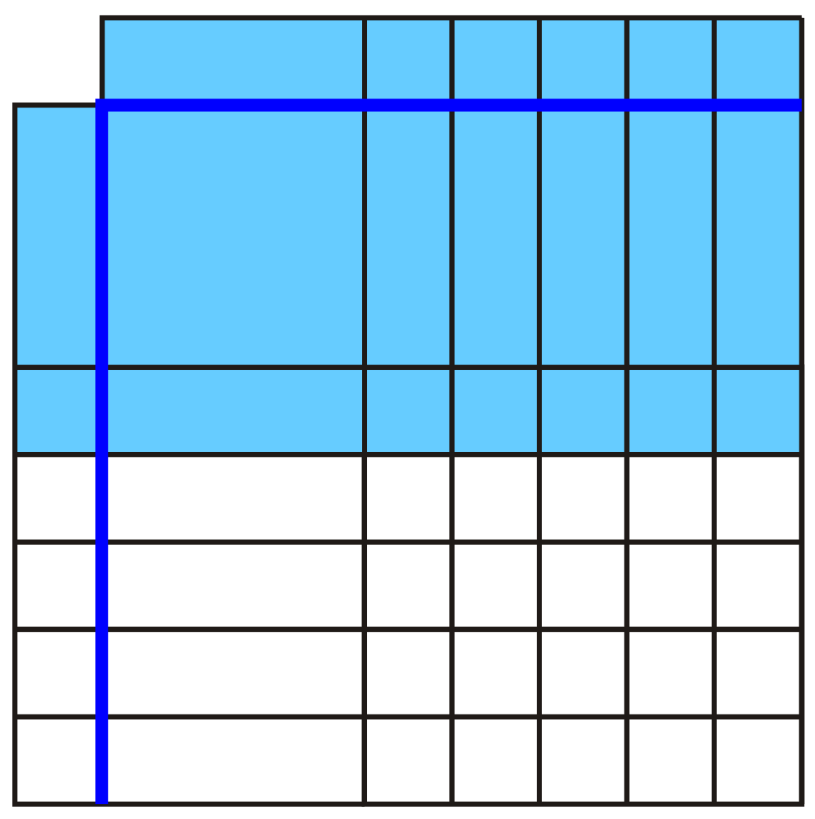 | y = x² + 6x +5
y = (x + 5)(x + 1) | 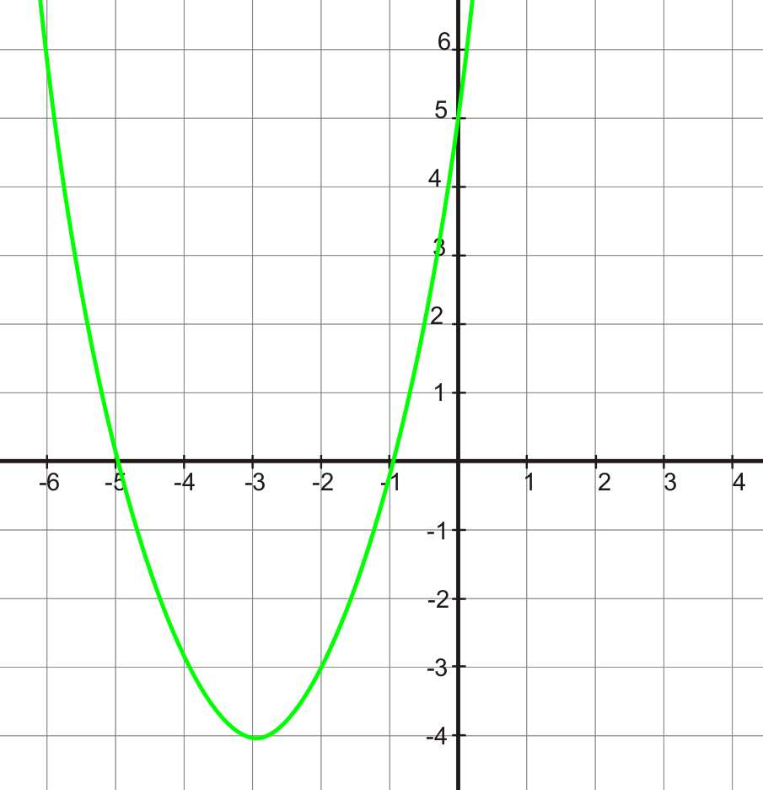
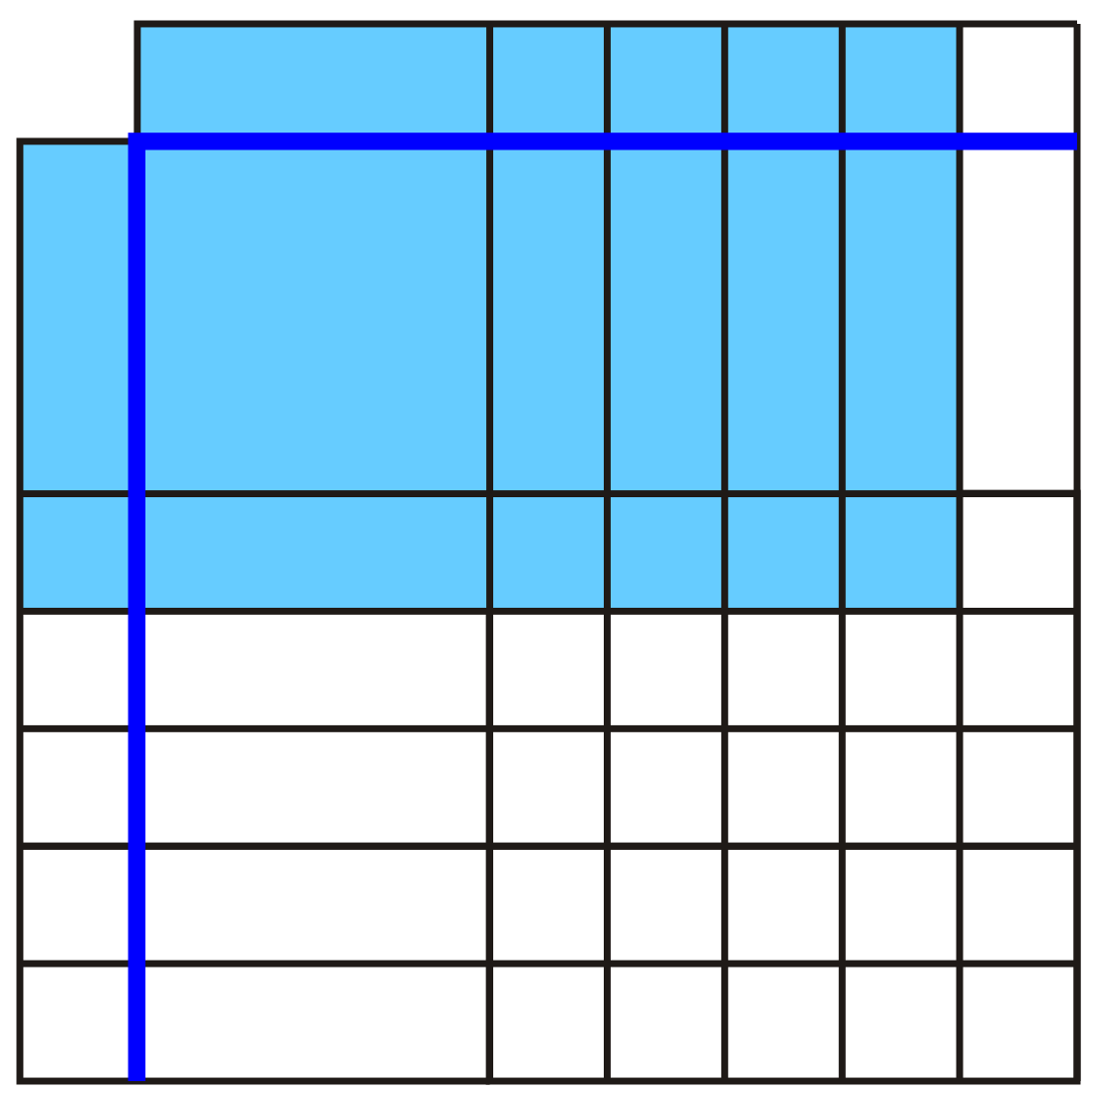 | y = x² + 5x + 4
6.5.1: Four Corners (continued)

y = (x + 1)(x + 4) | 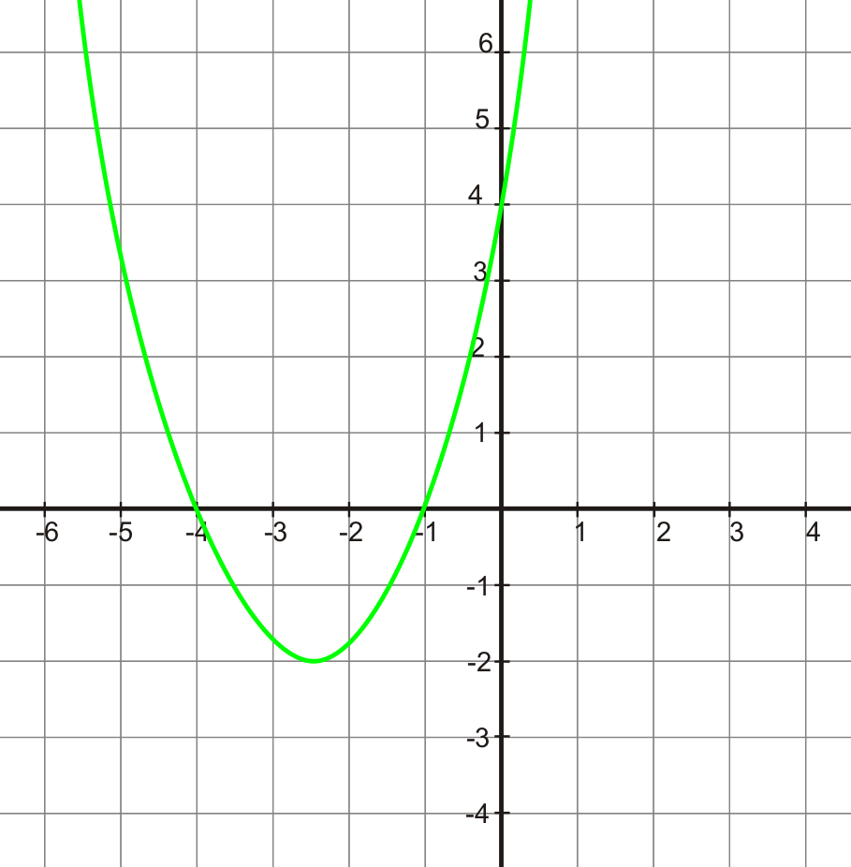
y = x² + 1x – 6
   | x | +3
  x | x² | +3x
  –2 | –2x | –6
y = (x + 3)(x – 2) | 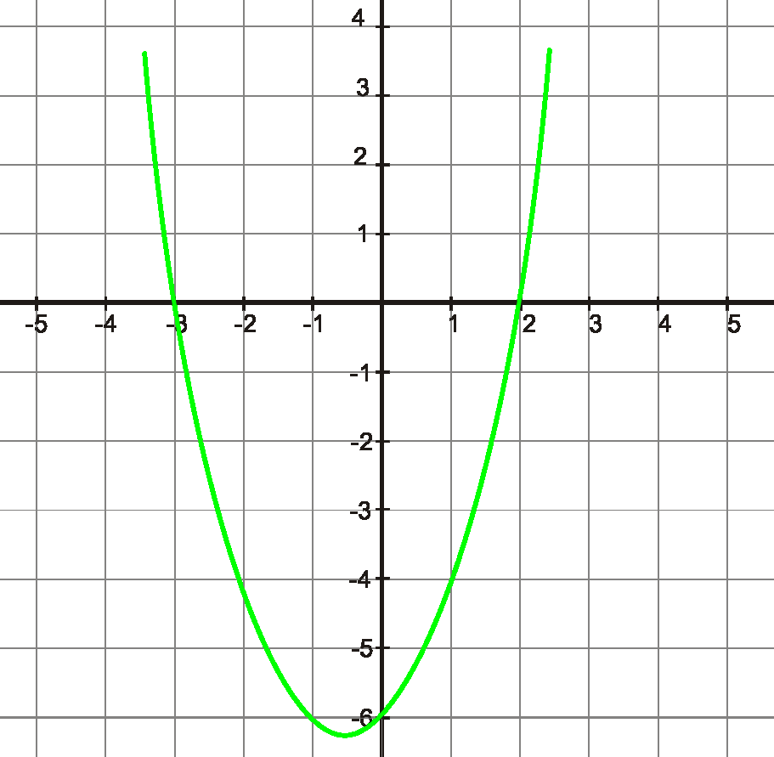
6.5.1: Four Corners (continued)

 | y = (x – 1)(x – 3)
  x | –1
  x | x² | –1x
  –3 | –3x | 3
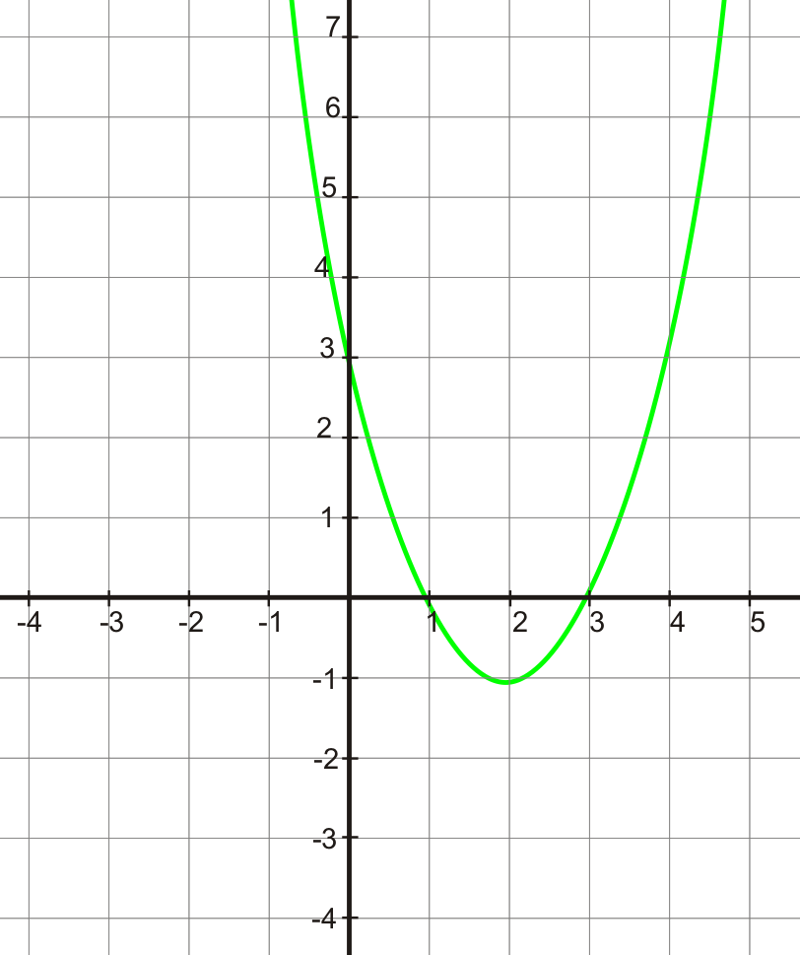 | y = x² – 4x + 3
y = (x – 3)(x – 4)
   | x | –3
  x | x² | –3x
  –4 | –4x | +12
6.5.1: Four Corners (continued)

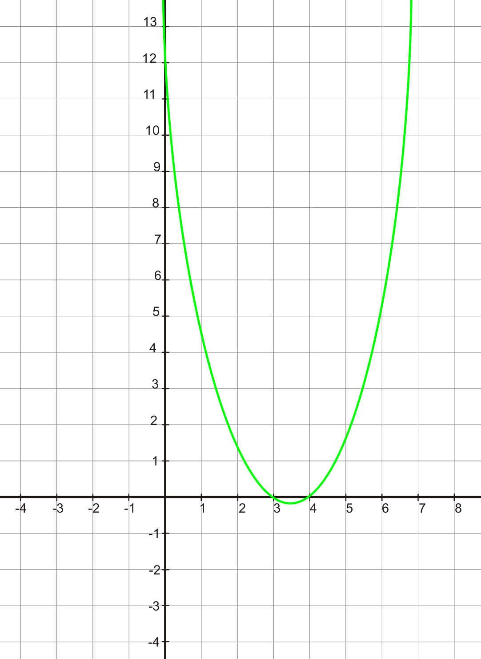 | y = x² – 7x + 12

6.5.2: Factored Form and x-Intercepts

Name:

Use algebra tiles to find the length and width for each given area. Use the graphing calculator to find the x-intercepts of the corresponding quadratic relation. Graph both the area model and factored form of the quadratic relation to check that these are the same before finding the
x-intercepts.
Area | Length | Width | Factored Form | First  x-intercept of corresponding relation | Second  x-intercept of corresponding relation
x² + 4x + 3
x² + 5x + 6
x² + 6x + 8
x² + 7x + 12

1. What do you notice about the constant term in the length and width expressions and the coefficient of the x term in the area expressions?

2. What do you notice about the constant term in the length and width expressions and the constant term in the area expressions?

3. If an area is expressed as x² + 10x + 21, what must be true of the constant terms in the length and width expressions?

4. If the standard form of a quadratic relation is y = x² + bx + c, and it has x-intercepts of r and s, then the same relation would then be y = (x – r)(x – s). How would you find the value of
r and s?

6.5.3: Match It!

Name:

Match each pair of numbers on the left with the correct product and sum on the right.
Pair of Numbers |  | Product and Sum
1. | r = –1, s = –5 | a. | r × s = 5  r + s = 6
2. | r = 1, s = 6 | b. | r × s = –5  r + s = –4
3. | r = 2, s = –3 | c. | r × s = –5  r + s = 4
4. | r = 1, s = –5 | d. | r × s = 5  r + s = –6
5. | r = –3, s = 4 | e. | r × s = 6  r + s = 7
6. | r = –1, s = 5 | f. | r × s = 6  r + s = –7
7. | r = –6, s = 2 | g. | r × s = –6  r + s = –1
8. | r = 1, s = 5 | h. | r × s = 12  r + s = 13
9. | r = –1, s = –6 | i. | r × s = –12  r + s = –4
10. | r = 1, s = 12 | j. | r × s = –12  r + s = 1

Unit 6: Day 6: Use Intercepts to Graph Quadratic Relations |  |  |  |  | Grade 10 Applied
75 min |  |  | Math Learning Goals  - Consolidate factoring.  - Connect factors to the x-intercepts of the graph of the quadratic relation.  - Graph quadratic relations, using intercepts. |  | Materials  - BLM 6.6.1  - large chart (grid) paper
Assessment
Opportunities
 | Minds On... |  | Pairs → Review  Students discuss their journal entry from Day 5 and refer to their answers on BLM 6.5.1 and 6.5.2.  Pairs factor the following quadratic expressions, discuss what is the same and different about each, and how the results would correspond to the x-intercepts of the corresponding relation:  x² + 11x + 30, x² – 11x + 30, x² – x – 30, x² + x – 30.  Curriculum Expectation/Observation/Checklist: Listen to students’ conversations to identify level of understanding of factoring trinomials and the connection between the factors and the x-intercepts. |  |  | Include some examples where the parabola is opening downward, and where there is a double root.  Note the use of the word sketch. The graph is not intended to be exact, but to show the symmetry, the intercepts, and the general movement of the curve.  Students can visualize and draw their solution in the air also.  Some students may still need algebra tiles to factor.
 | Action! |  | Whole Class → Demonstration  Using large chart (grid) paper, place a dot on the x-axis at –4 and 2, and a dot on the y-axis at –8. Point out the –4 and 2 are the x-intercepts and –8 is the  y-intercept of a parabola.  Ask volunteers to sketch the parabola that goes through these points. Point out that, at this time, they are focusing on the symmetry of the parabola, and that the parabola intersects correctly on the y-axis, and the x-axis. Repeat this several times using other values for the intercepts.  Discuss question A on BLM 6.6.1 and do question B together. Refer to question F to be sure students understand what is different in this question.  Individual → Practice  Students complete BLM 6.6.1.  Students who finish early can assist students who are having difficulty, and/or put an answer on the overhead and make a sketch of the relation on large chart (grid) paper.
 |  | Consolidate Debrief | Whole Class → Discussion  Students check their answers using the response on the overhead and on the chart paper grid.  Lead a discussion that compares graphing linear relations using intercepts and quadratic relations using intercepts. Discuss how factoring provides an efficient method for making a sketch of the graph, recognizing that it is a sketch only.
Differentiated  Exploration  Reflection |  |  | Home Activity or Further Classroom Consolidation  Complete the practice questions. |  |  | Provide students with appropriate practice questions.

6.6.1: Use Intercepts to Graph It!

Given the standard form of the quadratic relation, identify the value of the sum and product needed to factor. Express the relation in factored form, identify the x-intercepts and y-intercept, and use these results to make a sketch of each parabola.

 | Standard Form | Product  and Sum | Pair of Numbers | Factored Form | x-intercepts | y-intercept
A |  | r × s = 5  r + s = 6 | r = 1,  s = 5 |  | –1 and –5 | 5
B |  | r × s = –5  r + s = –4
C |  | r × s = –5  r + s = 4
D |  | r × s = 5  r + s = –6
E |  | r × s = 6  r + s = 7
F |  | r × s =  r + s =
G |  | r × s =  r + s =
H |  | r × s =  r + s =
I |  | r × s =  r + s =
J |  | r × s =  r + s =

Sketch of the relation

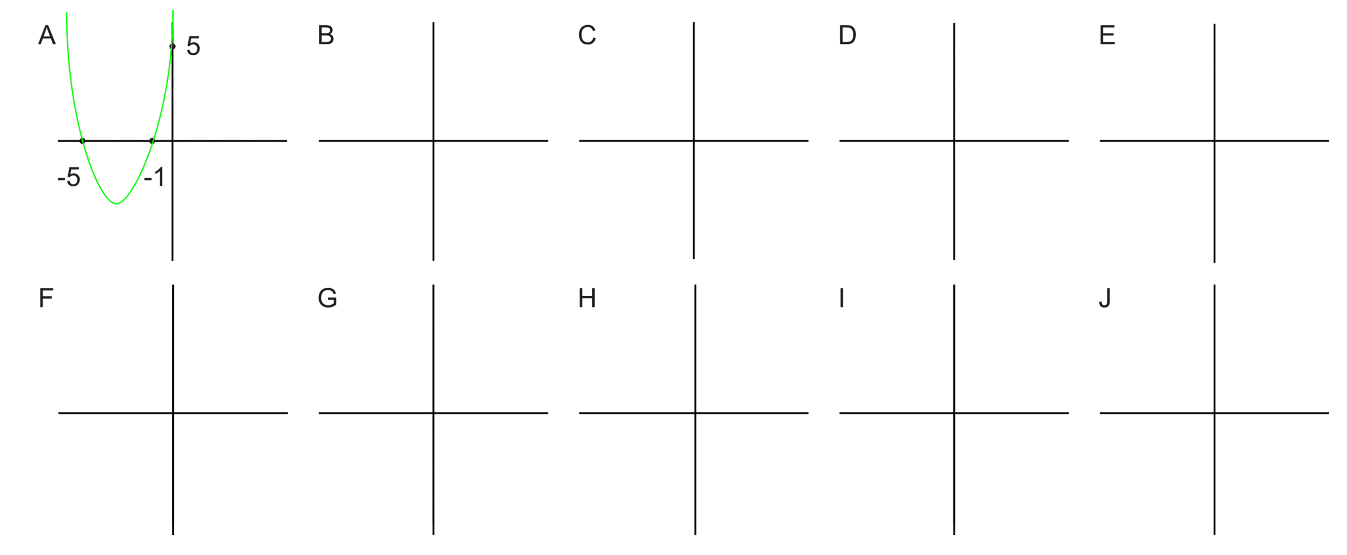
6.6.1: Use Intercepts to Graph It! (Answers)

 | Standard Form | Product  and Sum | Pair of Numbers | Factored Form | x-intercepts | y-intercept
A |  | r × s = 5  r + s = 6 | r = 1  s = 5 |  | –1 and –5 | 5
B |  | r × s = –5  r + s = –4 | r = 1  s = –5 |  | –1 and 5 | –5
C |  | r × s = –5  r + s = 4 | r = –1  s = 5 |  | 1 and –5 | –5
D |  | r × s = 5  r + s = –6 | r = –1  s = –5 |  | 1 and 5 | 5
E |  | r × s = 6  r + s = 7 | r = 1  s = 6 |  | –1 and –6 | 6
F |  | r × s = 9  r + s = –6 | r = –3  s = –3 |  | 3 | 9
G |  | r × s = –6  r + s = –1 | r = 2  s = –3 |  | –2 and 3 | –6
H |  | r × s = 12  r + s = 13 | r = 1  s = 12 |  | –1 and  –12 | 12
I |  | r × s = –12  r + s = –4 | r = –6  s = 2 |  | 6 and –2 | –12
J |  | r × s = –12  r + s = 1 | r = –3  s = 4 |  | 3 and –4 | –12

Unit 6: Day 7: We Have a Lot in Common |  |  |  | Grade 10 Applied
75 min |  | Math Learning Goals  - Determine the connections between the factored form and the x-intercepts of the quadratic relations y = x² + bx. |  | Materials  - graphing calculators  - algebra tiles  - overhead algebra tiles  - BLM 6.7.1, 6.7.2, 6.7.3
Assessment
Opportunities
 | Minds On… | Whole Class → Discussion  Use the context of kicking a soccer ball. Depending on the kick, the ball may travel different heights and distances. Lead a discussion as to how to draw a height vs. horizontal distance graph for three scenarios in which there are different height and distance measures.  Ask:  - If you were to represent this scenario graphically:  - what are appropriate labels for the axes? [height above ground in metres; horizontal distance from the kicker’s toe in metres]  - where would the point be that represents the kick?  - what would one of the x-intercepts of the graph be?  - what might the general equation of the graph look like? |  | Answers  Same: zero as a  y-intercept, zero as one x-intercept, shape, and size, opening up  Different: the other x-intercept
 | Action! | Pairs → Group Investigation  Students work through the graphing calculator investigation (BLM 6.7.1).  Provide each pair with one of the following equations: y = x² + 4x, y = x² + 6x,  y = x² – 2x, y = x² – 5x. Pairs of students complete questions 1–3 on BLM 6.7.1.  Form groups of four where each student in the group has a different equation. Students complete questions 4–9 (BLM 6.7.1). They compare what is the same about their graphs and what is different and comment on the x-intercept,  y-intercept, and the general shape. Lead a discussion about the algebraic representations, e.g., y = x (x + 4), y = (x – 0)(x + 4) and y = (x + 4)(x – 0) being equivalent ways of expressing the equation y = x² + 4x in factored form.  Use algebra tiles to demonstrate common factoring of y = x² + 6x, then do Example 1 and 2 of BLM 6.7.2. Students complete BLM 6.7.2. (See Teacher  BLM 6.7.3.)  Mathematical Process/Using Tools/Observation/Anecdotal Note: Assess students’ use of graphing calculators and algebra tiles to identify the factors.  Whole Class → Demonstration  Relate the algebra tile method of factoring to the algebraic method. Demonstrate the algebraic method using several examples, including some with negatives.
 | Consolidate Debrief | Individual → Journal  Students describe the three methods of common factoring that were investigated in the lesson, and describe the connections of the factors to the x-intercepts of the corresponding relation.
Concept Practice |  | Home Activity or Further Classroom Consolidation  Complete the practice questions. |  | Provide students with appropriate practice questions.

6.7.1: Investigate Relations of the Form y = ax² + b

Name:

1. Obtain a graphing calculator and equation from your teacher.
2. Type in the equation (using the Y = button on your calculator). Key in zoom 6 to get the max and min from –10 to 10 on your window.
3. Fill in the table.
Your equation | A sketch of your quadratic equation  (including the x- and y-intercepts)
y =  Coordinates of x-intercepts  (_____, _____) and (_____, _____)  and the coordinate of the y-intercept (_____, _____) | 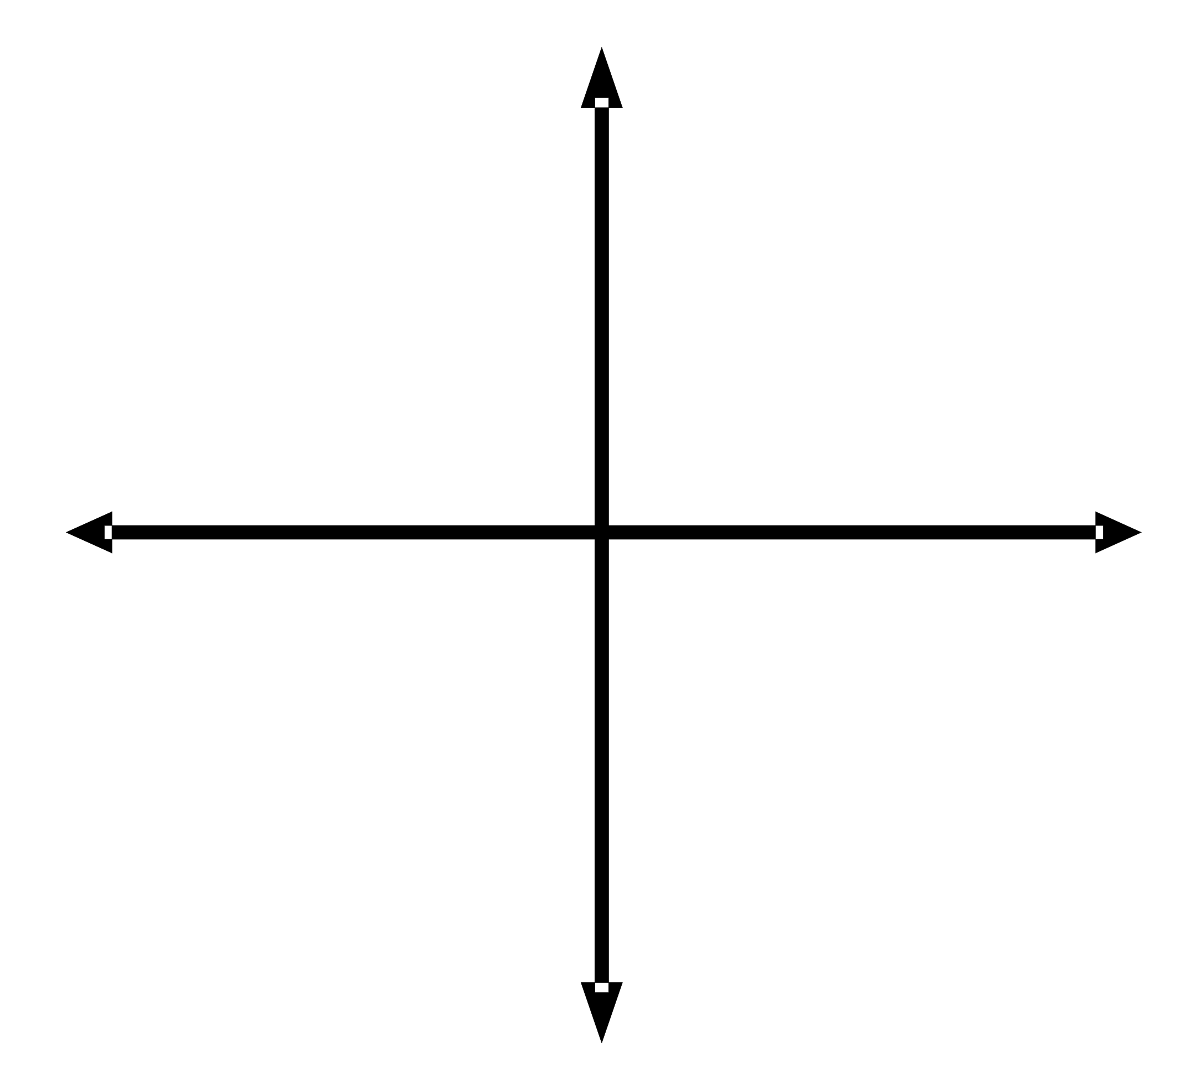

4. In your group, sketch all four graphs.
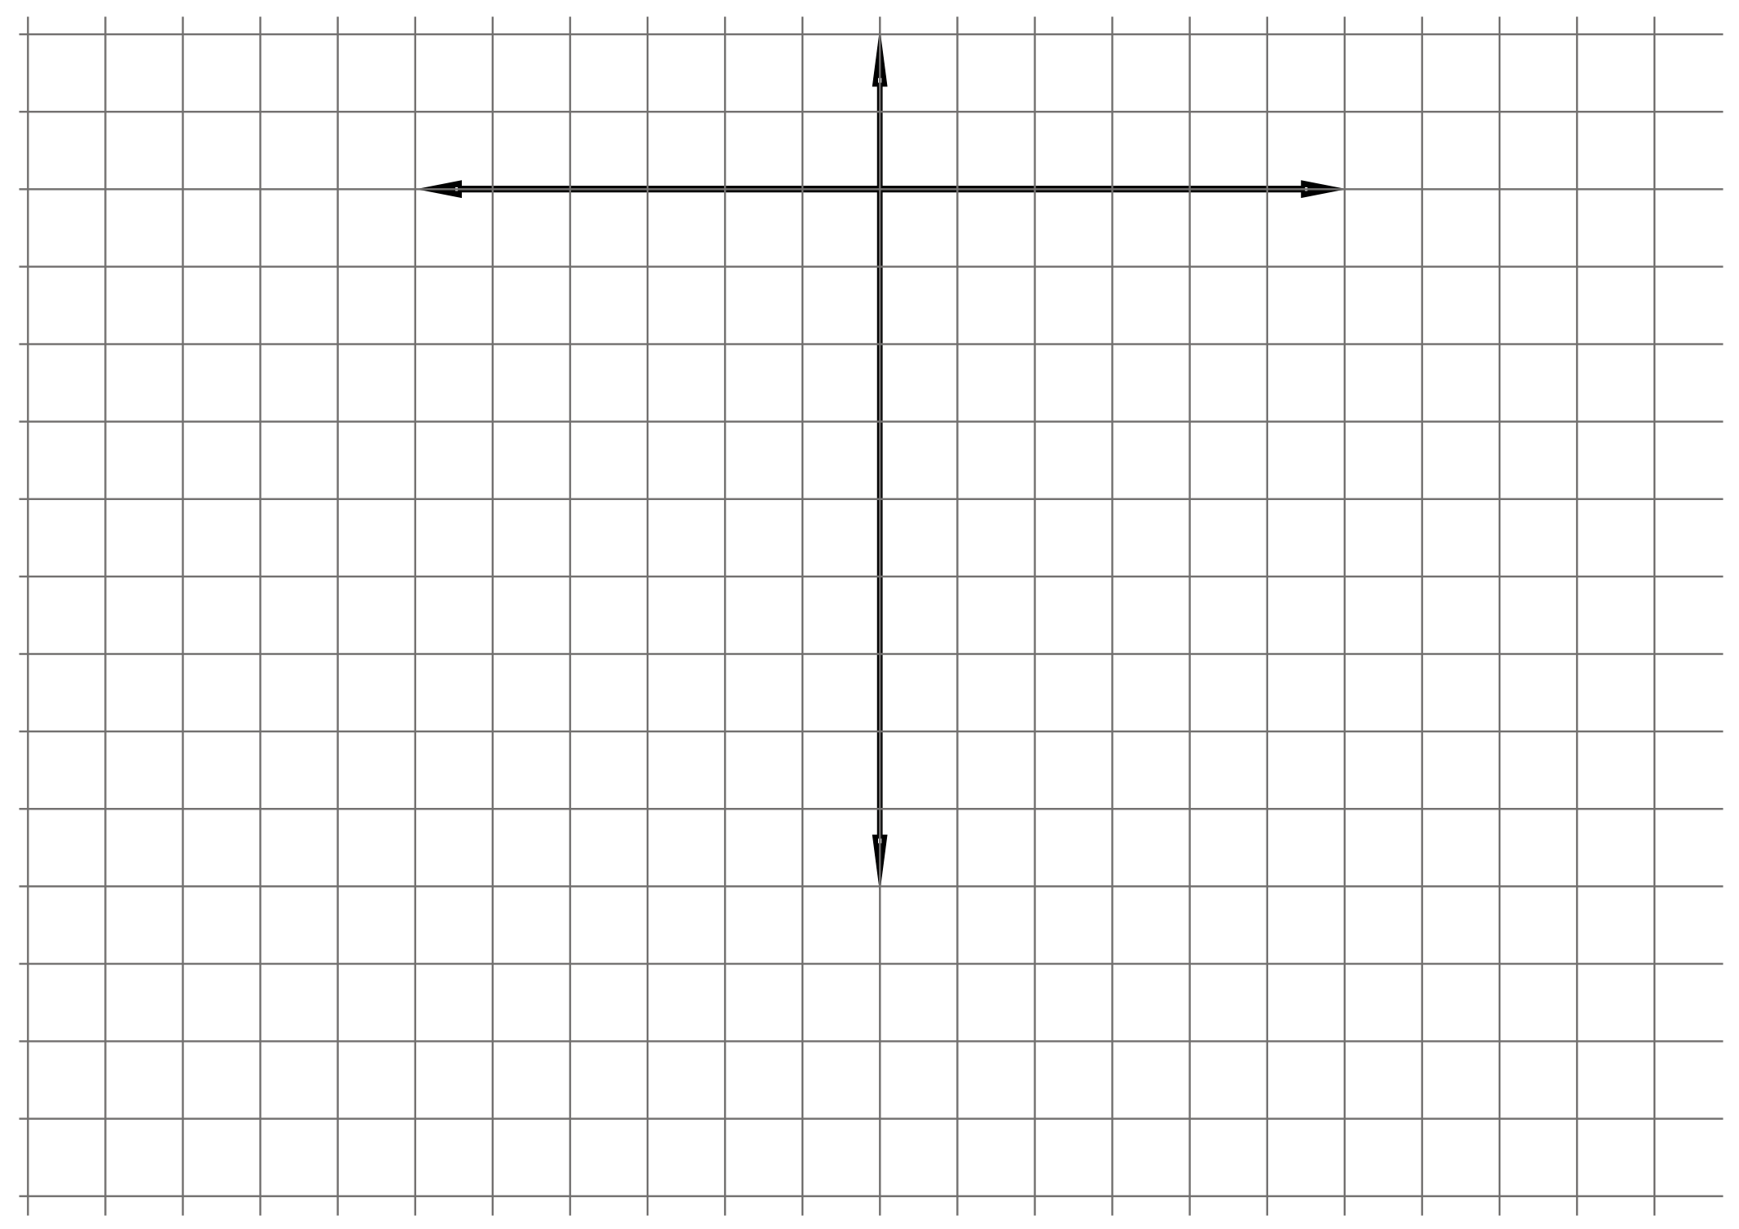

5. Identify what is the same and what is different in these four graphs.

6.7.1: Investigate Relations of the Form y = ax² + b (continued)

6. Fill in the following table.
Standard form | From the graph, identify the x-intercepts r and s | Write each equation in factored form  y = (x – r)(x – s)
y = x² + 4x | r = ____  s = ____
y = x² + 6x | r = ____  s = ____
y = x² – 2x | r = ____  s = ____
y = x² – 5x | r = ____  s = ____

7. Clear the y = screen on one of the four calculators, enter the factored form of the four equations, and graph. Are these graphs the same as the ones in your sketch?
If yes, continue to question 8. If no, revise and check. Ask your teacher for assistance, if needed.

8. Can the equations in the third column of your table be simplified? Explain.

9. Record the simplified versions of your relation in factored form.
Standard Form | Factored Form
y = x² + 4x
y = x² + 6x
y = x² – 2x
y = x² – 5x

6.7.2: Factoring x² + bx
Consider the outer portion of the algebra tile representation as the length and width of a room. The rectangle is the carpet. Colour in as many cells as required for each example to form a rectangle. To factor, form a rectangle using the tiles, then determine the length and width of the room.
Example 1: x² + 2x | Example 2: x² + 3x
factored form (______) ( ______)  the coordinates of the x-intercepts of y = x² + 2x  (______, ______) and (______, ______)  the coordinate of the y-intercept (______, ______) | factored form (______) ( ______)  the coordinates of the x-intercepts of y = x² + 3x  (______, ______) and (______, ______)  the coordinate of the y-intercept (______, ______)
Use your algebra tiles to factor the following:
1. x² + 4x | 2. x² + 1x
factored form (______) ( ______)  the coordinates of the x-intercepts of y = x² + 4x  (______, ______) and (______, ______)  the coordinate of the y-intercept (______, ______) | factored form (______) ( ______)  the coordinates of the x-intercepts of y = x² + 1x  (______, ______) and (______, ______)  the coordinate of the y-intercept (______, ______)
3. x² + 5x | 4. x² + x
factored form (______) ( ______)  the coordinates of the x-intercepts of y = x² + 5y  (______, ______) and (______, ______)  the coordinate of the y-intercept (______, ______) | factored form (______) ( ______)  the coordinates of the x-intercepts of y = x² + x  (______, ______) and (______, ______)  the coordinate of the y-intercept (______, ______)
6.7.3: Two Methods for Factoring x² + bx - Teacher

1. Algebra Tile Model for Common Factoring
Use overhead tiles to demonstrate the concept of common factoring for the example x² + 6x.

Explanation
This is the only rectangle that can be formed with algebra tiles. Factoring requires identifying the length and the width that results in this rectangle’s area. In this case the dimensions are (x) and (x + 6).

Alternative Explanation

Separate the x² tile from the x tiles to show the length and width of each part of the expression.
x
6
x
x

In the square, the area is given by x times x. In the rectangle, the area is given by x times 6. The total area is given by (x)(x) + (x)(6), we say that x is a common factor of each term.

Explain
x multiplies x, and x multiplies 6, thus x multiplies x and 6; that is, x multiplies (x + 6),
or x (x + 6)

Repeat the process with x² + 3x.

2. Algebraic Model for Common Factoring
Use the principle of what is common to each term to factor the right-hand side of each equation. Lead the class through algebraic thinking in factoring the following examples:

x² – 1x | x² + 5x | x² – 2x
= x (x – 1) | = x (x + 5) | = x (x – 2)

Unit 6: Day 8: What’s the Difference? |  |  |  | Grade 10 Applied
  75 min |  | Math Learning Goals  - Investigate the method of factoring a difference of two squares using patterning strategies and diagrams.  - Use the technique of factoring the difference of two squares to determine the  x-intercepts of a quadratic relation. |  | Materials  - graphing calculators  - BLM 6.8.1
Assessment
Opportunities
 | Minds On… | Individual → Reflection  Students reflect on the connection between x² – 36, y = x² – 36, and the corresponding graph. They fold a paper into thirds and write the headings  “I Think, I Wonder, I Know” in the columns. Students complete the first and second columns, and share their reflection with a partner.  Math Process/Communicating/Observation/Anecdotal Note: Assess students’ use of mathematical language related to quadratic relations. |  | The shaded area is x² – 49. You can see the two squares and the shaded area is the difference between their areas. When we factor, we want to find length and width of the rectangle having this area.  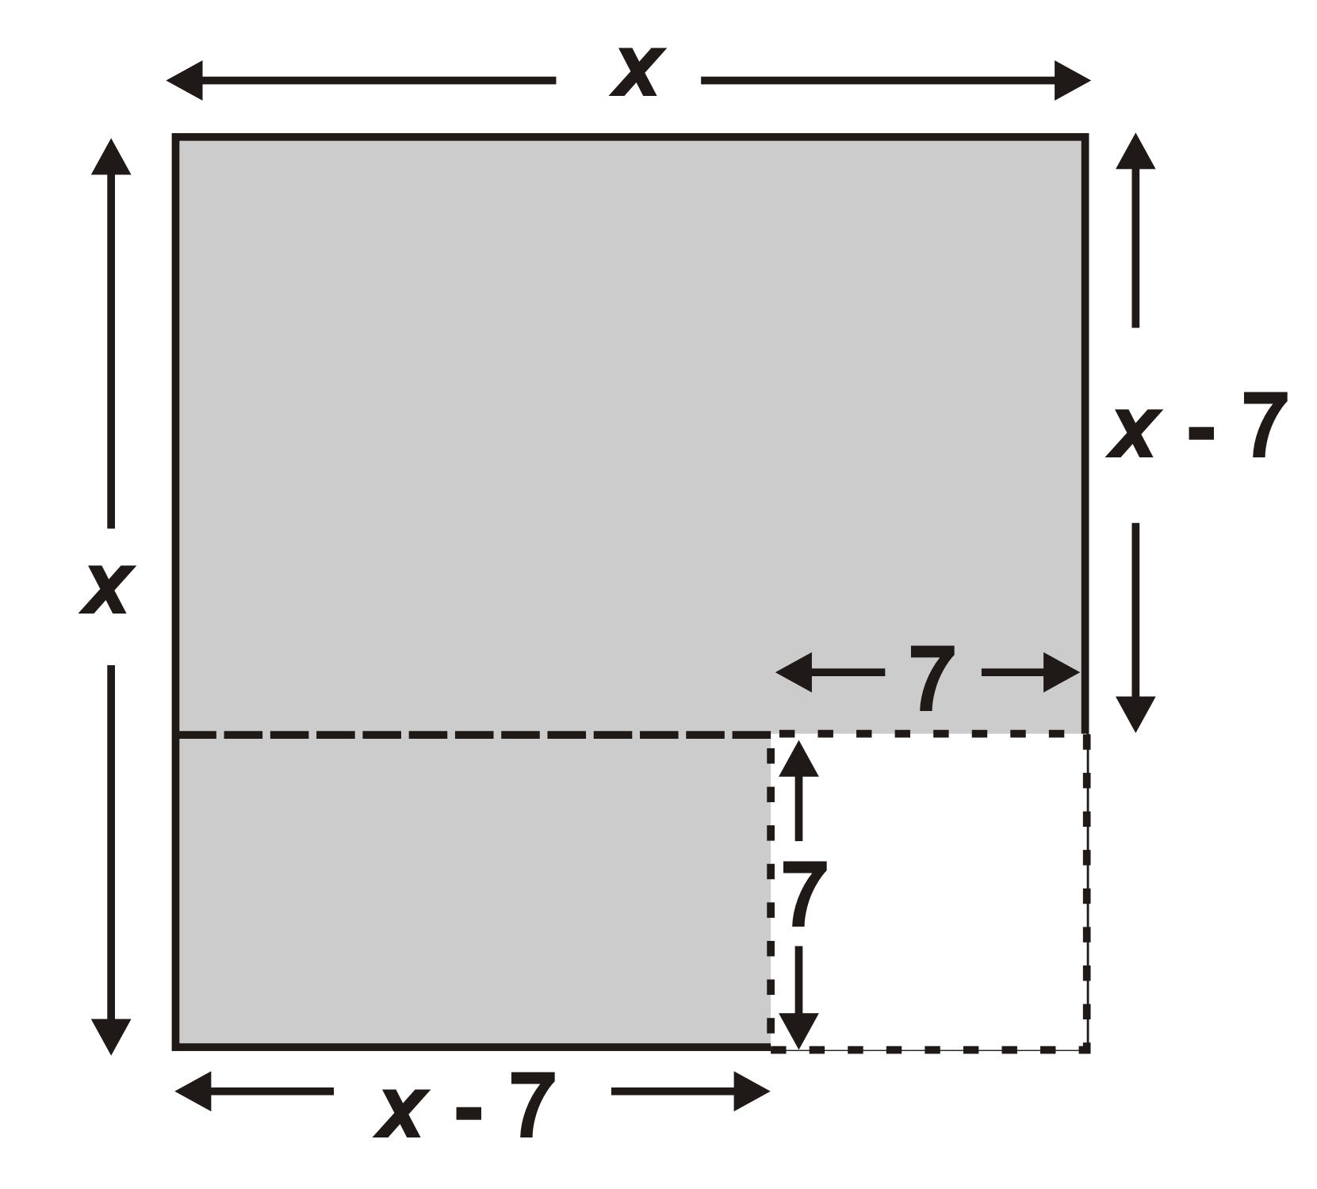  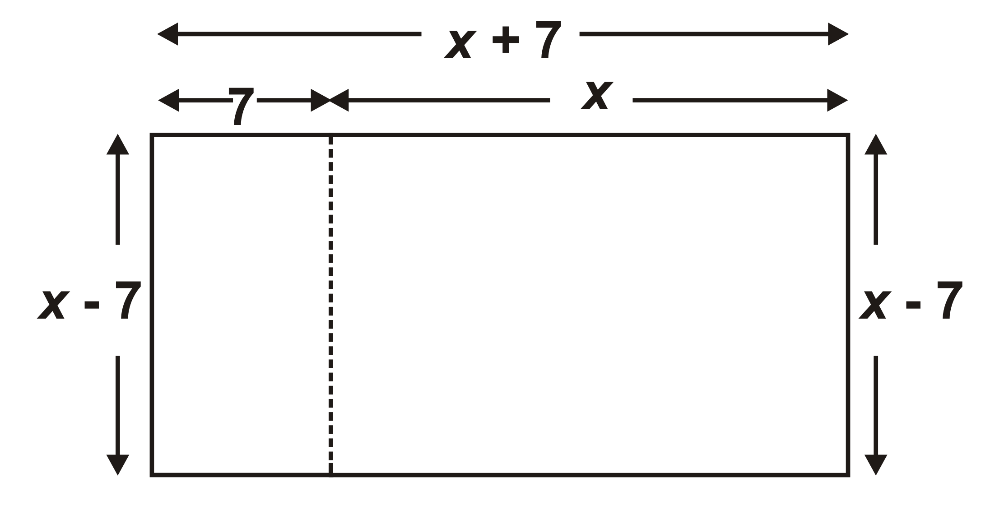  The length is x + 7 and width is x – 7.
 | Action! | Pairs→ Investigation  Students use a graphing calculator to identify the intercepts of quadratic relations of the form y = x² – a² and connect the x-intercepts to the factors (BLM 6.8.1).  Circulate to clear any misconceptions and to guide pairs, as needed.  Whole Class → Guided Instruction  Activate students’ prior knowledge by factoring the relation y = x² + 7x +12.  3 × 4 = 12, 3 + 4 = 7. Therefore y = x² + 7x + 12 can be expressed in factored form as follows: y = (x + 3)(x + 4)  Ask how y = x² – 49 could be written as a trinomial. [Answer: y = x² + 0x – 49]  Model the process: (+7)(–7) = –49 and (+7) + (–7) = 0  Therefore, y = x² – 49 can be expressed in factored form as y = (x + 7)(x – 7).  Reinforce the fact that the bx term is 0x and thus is not written in the expression. (Zero times x is zero.)  Explain why this type of quadratic is called a “difference of perfect squares,” illustrating both algebraically and pictorially.  Students practise solving problems involving factoring a difference of squares.
 | Consolidate Debrief | Whole Class → Discussion  Students complete the third column in their “I Think, I Wonder, I Know” chart.  Review factoring a difference of squares and its connection to the graph, as needed.
Practice |  | Home Activity or Further Classroom Consolidation  Practise factoring and connecting the factors to the graph.

6.8.1: Graphing Relationships of the Form y = x² – a²

Name:

1. Working with a partner and one graphing calculator, set your Window: Xmin = –10;
Xmax = 10; Xscl = 1; Ymin = –36; Ymax = 10; Yscl = 1; Xres = 1.
Complete the following table.
 | Relation in standard form | Sketch each graph.  Label as A, B, C, D, or use different colours. | y-  intercept | x-  intercept (r) | x-  intercept (s) | Relation in factored form  y = (x − r) (x − s)
A | y = x² – 4 | 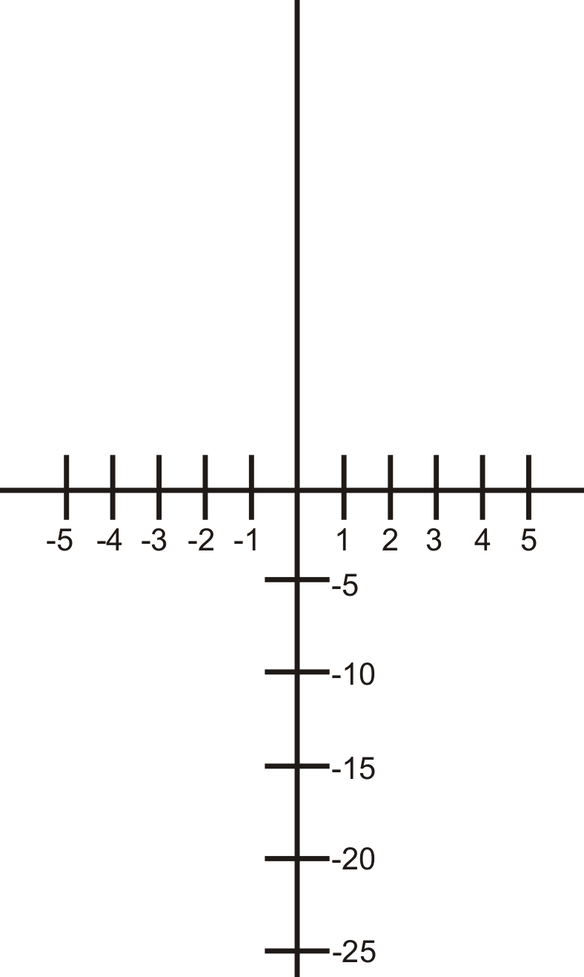
B | y = x² – 9
C | y = x² – 16
D | y = x² – 25

Consider your results from question 1 and answer the following questions.
2. What is the same about the relations?

3. What is the same about the graphs?

4. What is the same about the vertex of each graph?

5. What do you notice about the r and s values of each relation?

6. Solve this puzzle. How can you find the y-intercept and the x-intercepts of the graph of a quadratic relation of the form y = x² – a²?
Unit 6 Day 9 : Quick Sketches of Parabolas |  |  |  |  | Grade 10 Applied
Minds On: 15 Min. |  |  | Math Learning Goals  - Use factoring techniques to find zeros and use understanding of the connection between the equation and the y-intercept and symmetry to make “quick” sketches of the related parabola, given y = x² + bx + c |  | Materials  - graphing calculators  - BLM 6.9.1  - BLM 6.9.2  - BLM 6.9.3  - BLM 6.9.4
Action: 45 Min.
Consolidate/
Debrief: 15 Min
Total = 75 Min.
Assessment
Opportunities
 | Minds On… | Whole Class – Review  Review the key characteristics of a parabola (vertex, symmetry, y-intercept, zeros).  Review values in standard form of a parabola (a, b, c) and how that connects to the graph.  Review how to factor a trinomial (from standard form to factored form). |  |  | Use diagrams, descriptions, equations and draw connecting arrows between the various forms.  Performance Task or can be used as a Quiz or Observation
 | Action! | Whole Class - Discussion  Distribute BLM 6.9.1 to class. Review the first and third questions and allow students time to do the second and fourth questions. Go over work and correct any misconceptions and errors.  Curriculum Expectation/Oral Questions/Observation/Mental Note: Take up the first and third questions verbally and then observe how students demonstrate their understanding of factoring and graphing.  Individually - Activity  Distribute BLM 6.9.2 to students. They should work individually on matching equations from column A (standard form) to column B (factored form).
 | Consolidate Debrief | Pairs – Think, Pair, Share  Distribute BLM 6.9.3 – Each student graphs the equations shown. When finished, each student pairs up with one other student and compares graphs and the process they used to make them.  Mathematical Process/Communication/Oral Questions: Observe students as they graph the equations. Pose questions. Observe students explaining and sharing with others.
Concept Practice |  | Home Activity or Further Classroom Consolidation  Provide students with appropriate practice questions. |  |  | Consider providing students with a chart template like 6.9.1 to organize

6.9.1 Quick Review of Factoring and Graphing

For each of the following:
- identify what information the equation tells you about the parabola
- factor the equation and identify what the new form of the equation tells you
- sketch the parabola using the information you have (make sure you plot key points!)

Equation  (Standard Form) | Y-Intercept | Factored Form | Zeros | Sketched Graph
1. y = x²-7x+10

2. y = x² – x – 6

Equation  (Factored Form) | Zeros | Standard Form | Y-Intercept | Sketched Graph
3. y = (x – 2)(x – 5)

4. y = (x-3)(x+2)

6.9.2 Matching
- For each equation in column A, state the y-intercept.
- For each equation in column B, state the zeros (or x-intercepts)
- Each equation in column A has a matching equation in column B. Draw an arrow
Column A |  | Column B
Y = x² + 3x + 2  y-intercept = ______ |  | Y = (x – 3)(x + 2)  x-intercepts = _______________
Y = x² – 3x – 10  y-intercept = ________ |  | Y = (x – 3)(x – 2)  x-intercepts = _______________
Y = x² + x – 12  y-intercept = ________ |  | Y = (x + 4)(x + 2)  x-intercepts = _______________
Y = x² – 5x + 6  y-intercept = _________ |  | Y = (x + 2)(x + 1)  x-intercepts = _______________
Y = x² + 6x + 8  y-intercept = _________ |  | Y = (x – 3)(x + 4)  x-intercepts = _______________
Y = x² – 2x – 8  y-intercept = _________ |  | Y = (x + 5)(x + 2)  x-intercepts = _______________
Y = x² + 3x – 4  y-intercept = _________ |  | Y = (x – 5)(x + 2)  x-intercepts = _______________
Y = x² – x – 6  y-intercept = __________ |  | Y = (x – 4)(x + 2)  x-intercepts = _______________
Y = x² + 7x + 10  y-intercept = __________ |  | Y = (x + 4)(x – 1)  x-intercepts = _______________

6.9.3 Quick Sketches of Parabolas

For each quadratic function given below determine:
- The zeros (x-intercepts)
- The y-intercept

With the information you find and using symmetry, graph each parabola.

a) $y=x^{2}+6x+8$ | b) $y=x^{2}−7x+\text{10}$
c) $y=x^{2}−3x−\text{18}$ | d) $y=x^{2}−x−\text{30}$

Unit 6 Day 10: Applying Quadratic Relationships |  |  |  |  | Grade 10 Applied
Minds On: 15 Min. |  |  | Math Learning Goals  - Solve problems involving quadratic relations by interpreting a given graph or a graph generated with technology from its equation. |  | Materials  - graphing calculator  - overhead projector/screen  - graphing calculator screen  - BLM 6.10.1  - BLM 6.10.2
Action: 50 Min.
Consolidate/
Debrief: 10 Min
Total = 75 Min.
Assessment
Opportunities
 | Minds On… | Whole Class – Demonstration  Review graphing calculator functions for graphing quadratics.  BLM 6.10.1- Go through two basic problems with the class. Highlight what they need to think about as they dissect a problem and relate it to what they know about quadratics. |  |  | Clearing Data  Graphing Equations  Setting Window limits  Vertex, Zeros, etc.  Could be used as a Performance Task  Oral Questions – ensure students have made the connection between the parabola and its real-life meaning
 | Action! | Individual – Activity  Distribute BLM 6.10.2 and review the instructions – Students complete the first question individually while teacher walks around to monitor progress.  Mathematical Process/Connecting/Observation/Mental Note: Observation to see if students are applying skills to basic real-life situations.  Pairs – Activity  BLM 6.10.2 – Students should complete second question in pairs. Encourage discussion to assist decision making and problem solving process.
 | Consolidate Debrief | Whole Class –Reflection/Organizer  Wrap up questions for students to answer and make note of, for example:  - What do the zeros represent in a real life situation?  - What can the vertex tell us?  - What has the y-intercept represented?  Give students a graph and have them create questions about it that would show they can analyze the graph. If time permits, have students exchange their graphs and questions and practice answering the questions.
Application  Concept Practice |  | Home Activity or Further Classroom Consolidation  Provide students with appropriate practice questions.

6.10.1 Problem Solving with Quadratic Graphs-
Interpreting Parabolas

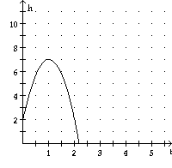
1. The graph below shows the height, in meters, of a diver jumping off a springboard versus time, in seconds.
- What is the initial height of the jumper? ____
What is this called in math terminology?

- Label and write the ordered pair of the vertex.
What does this mean in real life?

- Label and write the ordered pairs of the roots/zeros. What do these points mean in real life?

2. The graph below shows the height of a toy rocket after it is launched.
- How many seconds is the rocket in the air?

- What math concept did you use to determine this?

- What is the maximum height of the rocket?

- At what time does the maximum height occur?

- At what times is the rocket 120 meters above the earth?

- Complete the table of values below with first and second differences.

Time | Height | First Diff | Second Diff
0
1
2
3
4

g) What pattern did you observe in the second differences from the table? How does this prove that the relationship is quadratic?

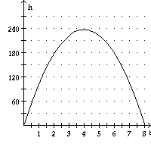


6.10.2 Applying Quadratic Relationships
There are many relationships that turn out to be quadratic. One of the most common is the relationship between the height of something (or someone) flying through the air and time.

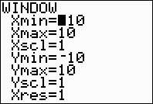
- A football player kicks a ball of a football tee. The height of the ball, h, in metres after t seconds can be modelled using the formula: h = -5t² + 20t.
  - Graph the relationship using your graphing calculator. Remember that you need to set your window settings. Record the window settings you used.
  - Sketch your graph in the window at right. Make sure to label your axes.



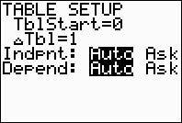
  - You can get the table of values for this relationship. Press ` and @ to access the table setup screen. Make sure your screen looks like the one given.

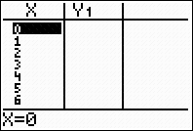
  - Now press ` and %. Fill in the window with the values you see.

  - For which times does the height not make sense? Why?

  - What is the initial height of the ball? __________

  - Where do you look in the table and the graph to determine the answer?

  - Why does this make sense?

6.10.2 Applying Quadratic Relationships (continued)

  - What is the maximum height of the ball? __________

  - Where do you look in the table and the graph to determine the answer?

  - When does the ball hit the ground? __________

  - Where do you look in the table and the graph to determine the answer?

  - When is the ball more 10 m above the ground? (You may need to give approximate answers.)

Playing Football on Mars

2. The force of gravity on Mars is less than half that on Earth. A ball thrown upward can be modelled using h = -2t² + 15t + 2 where h is the height in m and t is the time in seconds.

- Graph the relationship using your graphing calculator. Remember that you need to set your window settings. Record the window settings you used. You may need to play around with the settings until you see the full graph.

- What is the initial height of the ball? __________

- Explain what this means.

- What is the maximum height of the ball? __________

- When does the ball reach its maximum height? __________

- When does the ball hit the ground? __________

- When is the ball more 20 m above the ground? (You may need to give approximate answers.)

- If the same ball was thrown upward on the Earth, how would you expect the relationship to change?

- The force of gravity on Jupiter is much greater than on the Earth. If the same ball was thrown upward on Jupiter, how would you expect the relationship to change?

Unit 6 Day 11 : Review of Quadratics |  |  |  |  | Grade 10 Applied
Minds On: 10 Min. |  |  | Math Learning Goals  - Demonstrate ability to accurately apply quadratics lessons from the unit |  | Materials  graphing calculator  BLM 6.11.1  BLM 6.11.2  BLM 6.11.3 (teaching notes)  BLM 6.11.4
Action: 60 Min.
Consolidate/
Debrief: 5 Min
Total = 75 Min.
Assessment
Opportunities
 | Minds On… | Whole Class – Review  Review the key concepts and processes for quadratics.  Use FRAME organizer (BLM 6.11.1) to consolidate ideas and concepts for review. |  |  | Prepare a few key examples for students to look at and place in the frame model.  Students reflect on their learning to come up with ideas for each section of the FRAME model. Encourage students to look through their notes and examples.  Game questions are on BLM 6.11.2.  Teacher solution is on BLM 6.11.3.  It may be beneficial to refer students to a list of skills and concepts on the board or a word wall to answer questions 3 and 4.
 | Action! | Groups of 2-3 – Game  Students are placed into groups of 2-3 and are given an envelope with the first question in it. When they complete the first question, they come to the front of the class and pick another envelope and so on until the entire package is done. They can pick the order of questions that they do but all groups need to successfully complete all questions.  Mathematical Processes/Tool & Strategies/Checklist: Circulate around the class to ensure students have recalled the tools & strategies necessary to solve a quadratics problem OR debrief with the group before they receive their next question.
 | Consolidate Debrief | Groups of 2-3 - Self-Reflection/Discussion  Distribute BLM 6.11.4 - Students should take a few minutes at the end of class to discuss their team efforts as well as what skills they’re doing well at and what skills they still need to work on based on the review activity.
Application  Concept Practice  Reflection  Skill Drill |  | Home Activity or Further Classroom Consolidation  Assign additional review questions or give a practice assessment to students to complete.

6.11.1 FRAME (Function Representation And Model Examples)
Visual/Spatial/Concrete
Contextual
Graphical Model
Description/Key words
Tables of Values
Algebraic Models

6.11.2 Review of Quadratics

1. Linear vs Quadratic

- A linear relation forms a graph with a .

- A quadratic relation forms a graph with shape of a .

- Below is a table of value, determine if this relation is linear, quadratic or neither:
The relation is:

Time (x) | Distance (y)
Time (x) | Distance (y) | First Differences
 |  | First Differences | Second Difference

- A linear relation has the equal and the equal to .
- A quadratic relation has the equal.

6.11.2 Review of Quadratics (Continued)

2. Features of a Quadratic Graph
- A quadratic relation can be seen when a ball is thrown in the air and the height is measured versus time. A sketch of this graph might look:  This parabola is facing and the vertex is a . | - A quadratic relation can be seen when a duck flies into the water, catches a fish and flies back out:  This parabola is facing and the vertex is a .

- The key features of a quadratic graph are:

6.11.2 Review of Quadratics (Continued)

3. Forms of A Quadratic - Standard Form: y =ax² + bx + c

- The y-intercept is the or term.
- We can change factored into standard form by .
- There are three methods of expanding: , , and
- Example 1: Find the y-intercept, x-intercepts of the following quadratic:

y = (x + 4)(x – 5)

Method 1: Tiles | Method 2: Table | Method 3: Algebra (FOIL)

The y-intercept is:
The x-intercepts are: and

Example 2: Expand the following: y = 2x(3x – 4)

6.11.2 Review of Quadratics (Continued)

4. Forms of A Quadratic - Factored Form: y =(x – r)(x – s)
- There are two methods of factoring: algebra tiles and algebra
- Example: factor y = x² + 3x + 2 using tiles

- Product/Sum Form: Factor y = ax² + bx + c
- In this case r × s = c and r + s = b
- Find the x-intercepts of the following:
y = x² + 6x + 8 | y = x² – 3x – 18
- Common Factoring: y = ax² + bx
- Let us factor: y = x² + 3x
This can be written as:
Based on this r × s =
r + s =
The factored form is y = or
- Factor as state the x and y intercepts of:
y = x² + 6x | y = 2x² – 2x – 60
- Difference of Squares: y = ax² – b²
- y = x² – 4 can be written as y =
r × s =
r + s = factored form
y = x² - 16 | y = 2x² – 200

6.11.3 Review of Quadratics- Teacher

1. Linear vs Quadratic

- A linear relation forms a graph with a straight line.

- A quadratic relation forms a graph with shape of a parabola.

- Below is a table of value, determine if this relation is linear, quadratic or neither:
The relation is:

Quadratic since the second differences are the same.
Time (x) | Distance (y)
Time (x) | Distance (y) | First Differences
0 | 2 | First Differences | Second Difference
0 | 2 | 1 | Second Difference
1 | 3 | 1 | 2
1 | 3 | 3 | 2
2 | 6 | 3 | 2
2 | 6 | 5 | 2
3 | 11 | 5 | 2
3 | 11 | 7 | 2
4 | 18 | 7

- A linear relation has the first differences equal and the second differences equal to zero.

- A quadratic relation has the second differences equal.

6.11.3 Review of Quadratics - Teacher (Continued)

2. Features of a Quadratic Graph
- A quadratic relation can be seen when a ball is thrown in the air and the height is measured versus time. A sketch of this graph might look:  This parabola is facing Downward and the vertex is a Maximum. | - A quadratic relation can be seen when a duck flies into the water, catches a fish and flies back out:  This parabola is facing Upward and the vertex is a Minimum .

- The key features of a quadratic graph are:
Zeros

Vertex

Axis of Symmetry

6.11.3 Review of Quadratics -Teacher (Continued)

3. Forms of A Quadratic - Standard Form: y =ax² + bx + c

- The y-intercept is the last or c term.
- We can change factored into standard form by expanding .
- There are three methods of expanding: Algebra Tiles, Table Method, and Algebra (FOIL).
- Example 1: Find the y-intercept, x-intercepts of the following quadratic:

y = (x + 4)(x – 5)

Method 1: Tiles | Method 2: Table | Method 3: Algebra (FOIL)
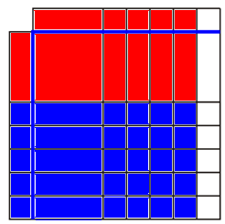 |  | y = (x + 4)(x – 5)  = x² – 5x + 4x – 20  = x² – x - 20
   | x | +4
  x | x² | 4x
  -5 | -5x | -20

The y-intercept is: -20
The x-intercepts are: -4 and 5.

Example 2: Expand the following: y = 2x(3x – 4)
y = 6x² – 8x

6.11.3 Review of Quadratics - Teacher (Continued)

4. Forms of A Quadratic - Factored Form: y =(x – r)(x – s)
- There are two methods of factoring: algebra tiles and algebra
- Example: factor y = x² + 3x + 2 using tiles
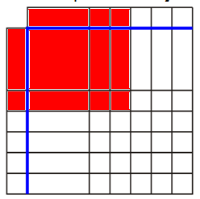

- Product/Sum Form: Factor y = ax² + bx + c
- In this case r × s = c and r + s = b
- Find the x-intercepts of the following:
y = x² + 6x + 8  2 + 4 = 6  2 × 4 = 8  y = (x + 2)(x + 4)  x-intercepts are -2 and -4 | y = x² – 3x – 18  3 + (-6) = -3  3 × (-6) = -18  y = (x + 3)(x - 6)  x-intercepts are -3 and 6
- Common Factoring: y = ax² + bx
- Let us factor: y = x² + 3x
This can be written as: y = x² + 3x + 0
Based on this r × s = 0
r + s = 3
The factored form is y = (x + 0)(x + 3) or x(x + 3).
- Factor as state the x and y intercepts of:
y = x² + 6x  = x(x + 6)  x-intercepts 0, -6  y-intercept 0 | y = 2x² – 2x – 60  = 2(x² - x - 30)  = 2(x +5)(x – 6)  x-intercepts -5, 6  y-intercept -60
- Difference of Squares: y = ax² – b²
- y = x² – 4 can be written as y = x² + 0x – 4
r × s = - 4
r + s = 0 factored form y = (x + 2)(x – 2)
y = x² – 16  = (x + 4)(x – 4) | y = 2x² – 200  = 2(x² – 100)  = 2(x – 10)(x +10)

6.11.4 Review of Quadratics - Reflection
After you’ve completed the review activity, answer the following questions in your group. If your answer involves circling a number, note that 5 is really well and 1 is poor.

1. Rate your contribution to your team’s efforts. (5 is the best rating, 1 is the poorest)
1 2 3 4 5

2. Rate your team-mate’s contribution. (5 is the best rating, 1 is the poorest)
1 2 3 4 5

3. Identify 2 areas of quadratics that you did really well at:

4. Identify 2 areas of quadratics that you need to work on a bit more:

5. What concept(s) would you like to have explained to you again?

6.11.5 My Notes

